WHITE PAPER 21: NATURENESS AND CLIMATE THERAPY
Republished with illustrations and new formatting by Project NatureConnect
See the original http://www.tjsssr.com/index.php/tjsssr/article/view/53
Enjoyably engage in it, free, at www.ecopsych.com/journalnatureness.html
________________________________________________________

Journal of Social Sciences Studies and Research (TJSSSR)
Volume02|Issue 04 (July-August)|2022|Page:175-191
Online ISSN: 2583-0457
TJSSSR is an international, double-blind, peer-reviewed
journal published online Bimonthly by MISJ.

Natureness In Action
The remedy for abuse that we learn to ignore:
Nature’s essence is its wordless love to begin life.

Michael J. Cohen

A WHOLE LIFE CLIMATE THERAPY IMPERATIVE

Organization Project NatureConnect, City: Friday Harbor, Washington USA
Organizatio Project NatureConnect Inc., City: Elkins, State: Arkansas USA
Correspond, Michael J. Cohen nature@interisland.net 360-378-6313
PREFACE
Natureness and the Green Switch Tool That Increases Personal-Social-Evironmental Justice and Well-Being.

"Our suicidal war with nature makes us face devastating new heights of global warming and species extinction along with new polarizing lows of mental health, ecological degradation and personal well-being. We suffer
setbacks in our work towards globally equitable, inclusive and sustainable development and relationships. To put it simply, the state of the planet is broken. Today’s defining task is to flick the green switch that makes peace and wellness."
- Antonio Gutteres, United Nations Secretary General (edited)

This article’s "Natureness" is the green switch that produces peace with Nature because it’s a tool that makes it happen. It heals the injured essence of what ails us by verbalizing it. It simply contracts “essence” into “ness,” (to be, to exist) and then adds it to everything in an attractive natural area or our pet. Our broken world become Maryness, Bobness, treeness, attractionness, climateness, windness, aliveness, rockness, starness et al. Then, as of old, all things, now reunited, in kinsip purely love each other into Nature’s balanced and beautiful well-being. That’s what we desperately need to wage peace.
- Michael J. Cohen, Ed.D., Ph.D.

“I went to a natural area I was attracted to and asked permission to 54-sense unify with it. I asked what my Natureness is at this time and had an experience of nature embracing me in the present, and also feeling as if I were in the ‘past’ at the same time, back to the teenager that would flee to nature when things got really tough. I was a teen, and I was the me now, simultaneously. I felt safety and well-being. I realized we are timeless as is nature. Nature stands for us day and night, over eons. Nature is there for us consistently; it never abandons us. My sense of belonging was attracted to this, as were my senses of safety, peace, nurturing, attachment, and my own truth.”

- Natureness Participant’s Journal

VALIDATION NOTICE: The contents of this green switch professional paper includes and accredits the cutting edge facts of Project NatureConnect, and its websites, personnel, certificates, courses, methods and materials.
https://www.projectnatureconnect.com/benefits/ www.ProjectNatureConnect.com
www.ProjectNatureConnect.org www.ecopsych.com/webstrings1000nat.html

The origin and validity of Natureness at Project NatureConnect is indisputable.
“I was born into a community of settlement house families who fled from persecution in Russia. They guarded well their freedoms in America and lived in innovative Sunnyside Gardens in NYC. In 1936, at age six, in elementary school my liberty to be left-handed was abused by being forced to write right handed so that my dip pen ink would not smear my writing and shirt, for the ink well was drilled into the right corner of the desk. That’s when my speech, nail-biting and posture disorders appeared. After three years of protesting this, my family argued the school into letting me write lefty using a fountain pen. This improved things and bonded me to finding reasonable solutions to challenges” (Cohen 2020).
"On an August day in 1965, a freak thunderstorm compelled me to ask the Grand Canyon Wilderness I was backpacking if it was alive and how its life was different than mine. No surprise, it said nothing because Nature doesn’t use words. Soon, however the answers became obvious.
"Nature couldn't speak and I/humanity could.”
“If Nature died, I’d die so Nature had to be alive.”
Without knowing it I had created a moment that let Nature's essence (Natureness) reinforce that most words are foreign to Nature’s life and produce side effects.
Nature is adulterated by our misleading labels and stories. Until they are corrected they injure its wordless perfection around, in and as us.”
- Michael J. Cohen

For the past 38 years Project NatureConnect has used and offered forms of Natureness, Nature’s self-correcting essence, as a potent climate therapy tool that anybody can incorporate to green switch restore our broken world and personal lives.
Natureness increases well-being by 850% when its used to
• Create a globally unifying atmosphere that makes any relationship increase person/planet balance and beauty.
• Help you and others be happier, increase your well-being and help others do the same as it strengthens resilience and reduces stressful conflicts, disorders and excessiveness.
• Stop the lies and corruption that infiltrate our lives so that we may sustain happy relationships and help others do the same.
• Reduce the health insurance premiums of those who engage in Climate Therapy while doing this reduces the health costs of insurance companies.
• Increasingly reward those who enjoy and teach therapeutic nature-reconnecting activities and create the joy of their beneficial person/planet effects."
• Be profitably offered by the pharmaceutical and medical profession as a potent preventative and means to hasten recovery from our disorders.
• Reduce the human service budgets of municipalities while improving personal, social and environmental health.
• Make immediate therapeutic contributions for conflict resolution on personal, local and global levels.
• Convert outdated dogma, philosophies and scriptures into today's spacetime knowledge to increase person and planet well-being.
• Improve the economy by reducing environmental costs and motivating environmental recycling, sustainability and wellness
• Give added value to natural areas to help industrial society’s story come into balance with natural systems in and around us.
• Strengthen mental health by relieving our stress and pain as we transform them into Natureness’s wordless attraction to begin life and love people, places things and us into being.
• Increase the responsibility and profitability of organizations that incorporate Natureness Climate Therapy into their management and operation.
• Produce a new human services Natureness economy that profitably trains and pays people to use, teach and reap the benefits of Climate Therapy.
For example, this article, can be divided into numbered sections as a guidebook for a numbered local nature trail or a theme park. It could also guide,.a corporation to profitably manage a government’s social programs 850% better than now.

ARTICLE

The Remedy for Abuse that we Learn to Ignore: Nature’s
Essence is its Wordless Love to Begin Life
Abstract
Objective I am a 92 year old personification of Nature’s wordless attraction (love) to begin life. As an Applied Ecopsychology ADP, commencing 1969, I spent 16 years directing year-long, utopian education, Nature-Connected Psychology expeditions independently and for the National Audubon Society. Travel-camping across the USA, we organized ourselves to scientifically create unifying natural area moments that let Nature’s life teach and heal us via its space-time essence instead of from our society’s suicidal war with Nature (Cohen 1998).
Methodology Since 1985, after initiating the world’s first “Is the Earth a Living Organism?” International Gaia Symposium, I created today’s Project NatureConnect online Organic Psychology activities, courses and degree programs. They let Nature’s heartfelt essence (Natureness) to become more attractive and interlace our 54-senses with Nature’s unconditional love, backyard or backcountry. It does this by knowledgeably adding ness to everything there including us. This 850% increases personal, social and environmental well-being as it transforms the abusive cause and pain of our problems into Nature’s self-correcting balance and beauty. “You become Youness” as this article warmly unites folks through evidence-based Natureness truths.
Discussion Professional journals and field experiences validate my 1965 hypothesis: “Teaching myself and others to practice and teach Natureness achieves my Objective, (above.) and increases well-being everywhere.” This article/tool adds global wellness to applying the absolute truth that “You are reading these words here and now.” That, alone is a “magic wand” it waves and increases well-being. In 1965, in a wilderness area, that self-evident fact demonstrated that because I (humanity) can speak with words and Nature cannot, devoid of Natureness, our stories excessively disconnect us from Mother Nature. To compensate for this loveless, hurtful loss and abandonment by her greater attractiveness, we constantly crave artificial satisfactions from Earth’s natural resources, its metabolism, around, in and as us. Tragically, this 45% to 75% deficit has bankrupted and broken our person/planet life and counting.
Conclusion This article creates heartfelt natural area moments that let our 54-senses interlace with, since forever as now, Nature’s wordless attraction (love) to begin life and dance it into being, everywhere, all at once, moment-by-moment. Its organic wisdom remedies todays ecocide through therapeutic practices that make our experiences become beneficial person/planet relationships when we relate to the natural essence of things instead of just their labels or stories.
Abstract of IJPSS facts in this article.

Industrial Society has made us suffer ‘Earth Misery’ a runaway, natural resource, species and mental illness catastrophe that deteriorates personal, social and environmental well-being by ignoring its homeostatic space-time remedy. The latter has helped the life of Earth activate our 54 natural senses to reverse the nature-disconnected relationships that produce our disorders and crippling budgets. Without producing garbage, Nature creates optimums of life, diversity, cooperation, love, balance and well-being while our society detaches 98 percent of our life from this wisdom. Five decades of space-time, Organic Psychology research in natural areas exploring “attraction being conscious of what it is attracted to” has shown this nature-connected learning process validates our sensations and feelings as facts of life. It empowers scientific methodology to happily restore our missing whole-life, multiple sense integrity. Funded and internet available, backyard or back-country this Climate Therapy tool has helped people create phenomenal moments that let Earth teach and heal (Cohen, 1998).

Introduction

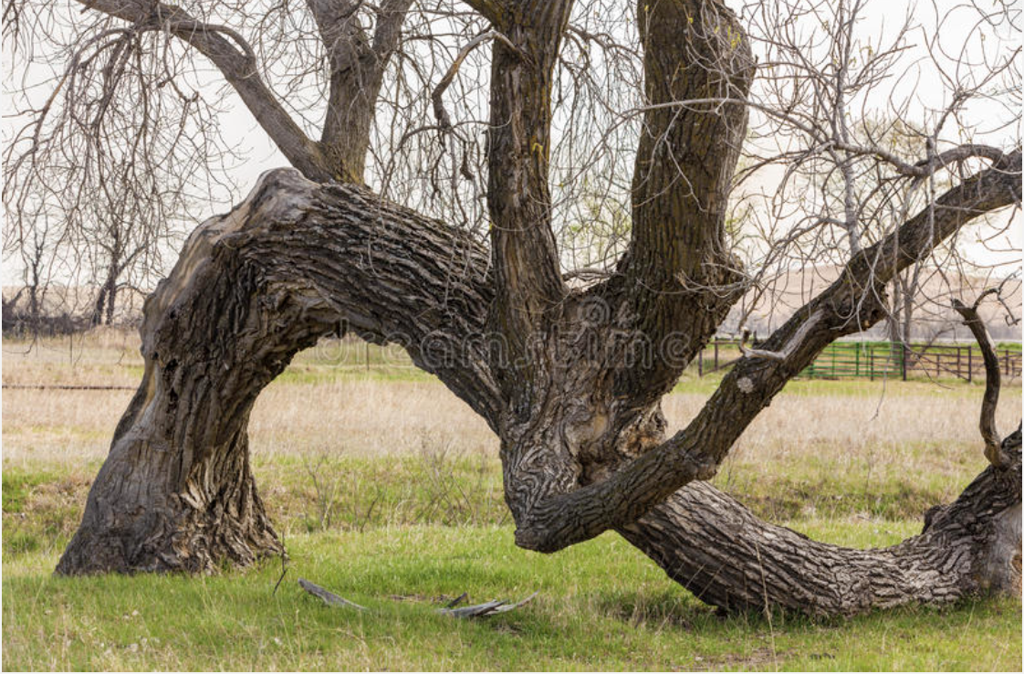
Felt senses are legitimate things. A selfie taken by the sense of gravity (sense #11)
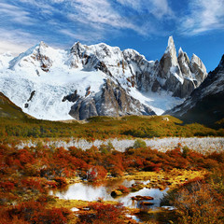
As a twig is bent, so grows the tree. Similarly, today we painfully break our world because we are born into, attached to, and warped by our society’s undue prejudices and war against Nature. Their lies create our hurtful personal and global climates (Cohen, 1983, 1991,) because prejudice is an unreasonable, pre-judging attitude that is, due to bonding, unusually resistant to sensible influence.
When applied to Nature, the war’s destructive propaganda makes it seem rational for us to become abusive ecozombie pirates that conquer Nature’s life, around, in and as us. However, Nature’s resources are also our life-support system (Cohen. 2002). Our war with Nature is a madness that could be called suicide by piracy or ecocide.
Since our prejudice emotionally attaches us to misrepresentations, we abhor or deny the existential Pristine Truth essence that corrects them. This learn-by-doing article is that inspiring Pristine Truth. I care about it because I spent 71 years studying and invoking its person/planet source while in natural area relationships. (Cohen, 1993). You may care too because as you read this it’s becoming your truth of this moment in context with Natureness, the Pristine Truth essence of our space-time Universe’s wordless eons of life. You can strengthen your caring by right now adding “ness” to your first name. For example, like “Jodi” would become “Jodiness,” “you” become “Your Nameness,” A tree becomes “treeness.” You grow as this “Natureness” narrative continues. As its essence progresses, so do you.

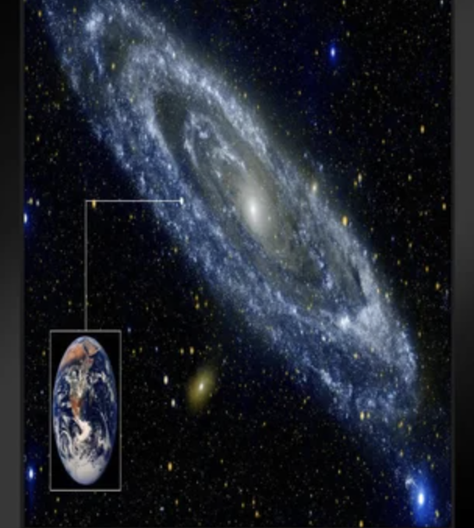
Natureness Moment-by-moment, as space-time, the essence of Nature’s life is wordlessly attracted (loves) to begin its “Aliveness,” “Your-Nameness,” “Treeness,” “Jodyness,” “Oneness,” “Wholeness,” “Earthness” “Happiness” etc.

This article is pleasantly organic. On these self-updating pages it’s nature-connected psychology develops itself into a practical and applicable social technology, Natureness, that continually strengthens our Pristine Truth so we can apply it anywhere, anytime, to the essence of any relationship, thing, discipline or transition.
In any moment this narrative’s existential power of Natureness can convert each of our distortions and their abusive effects into 54-sense, uplifting scientific facts (Cohen, 2017). They increase well-being anywhere, by 850%, (54 senses instead of five) as they help our kindness help others do the same individually or in an online independent community.
Thankfully, in 1949, our mechanistic Newtonian Universe’s entropy and chaos model was proven inaccurate as Earth’s resource depletions were discovered. The model was updated and replaced by the discovery of the life of today’s, space-time, “Big Bang” Universe. Its flow consists of, since forever as now, Nature’s wordless attraction (love) to begin life and dance it into being, moment-by-moment. In and as it, the essence of all things exists in any moment since it includes the past and future and our thoughts and feelings. It’s as real and true as is this instant because it is it, everything everywhere all at once.
As part of the life of the Universe and Nature, we are conceived and born with its desire to be nurtured and grow to survive. We experience this 54-felt-sense fact because without being nurtured by Nature’s wordless love, we can’t continue to live. This feeling is self-evident. It’s rooted in every breath we take, yet we are educated to ignore its significance. Check it out. Hold your breath and sense your love to breathe as it expresses itself as suffocation feelings. Even if you pass out, Nature’s love for your life will apply authentic breathing to revive you, not artificial respiration (Cohen, 1997). Note how easily this sensory truth validates itself because we are it and own it. It fills our mind, we’ve seen it happen and have learned from it, yet wanting to breathe is not one of our five senses. As we proceed, these pages simply grow and reinforce the essence of our 54-sense longing for air (Cohen, 1997). By 850%, this narrative replaces our prejudicial, inanimate and entropic thinking and its people-centered, pirate-the-Earth tragedies (Cohen, 2001).

Felt senses are facts: A selfie taken by the sense of distress (sense #26)
These paragraphs compassionately enhance the Natureness remedy for our outdated, mechanistic Universe and its war with Nature..
Today, sadly, our nature-disconnecting stories continue to create the misery we suffer (Cohen, 2020c). This is an emergency. Personally, locally and globally wouldn’t you love to reduce our abuse from our agonizing falsehoods and solastalgia hurt (Mallory, 2017).

Natureness Exhibits

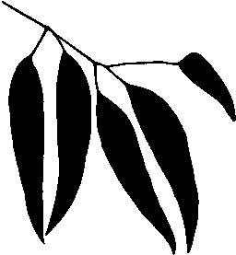”Ness” is “to be or exist”
Pristine Truth Exhibit 1. As stated, obviously, our education’s bias has scientifically indoctrinated us to endure being ecozombie pirates whose lies, thefts and murders break our world. In response, this article is a 54-sense spacetime
practice whose facts transform our pirating into Nature’s essence (Natureness) experiences that unify things globally locally and within us (Cohen, 2022). If you read this article as your essence (Youness), you become involved with its truth, make it happen and love it, especially if you want to live in sane wellness and justice rather than the pirating that stems from our prejudicial lies about Nature.
To be able to write this piece, I’ve spent my past 56 years, living and learning, with others in 84 different natural habitats, to strengthen humanity’s nurturing abilities and reduce our ill-treatment of each other (Cohen, 1998). For this reason, the narrative validates that Nature is the fountainhead of authority and history of how its perfections work. As aforementioned I establish that since before forever, as now, Nature is its wordless attraction (love) to begin life’s dance that loves things into being, living and growing. Whenever we excessively disconnect from this Natureness singularity we create a personal and global want for Nature’s absent love to be reinstated. (Again, hold your breath to experience this.) Then this article enables Natureness to reinstate it, as only Nature’s essence can, so we don’t continue to suffer from our deprivation of its lifegiving embrace (Cohen, 1993).
Natureness let’s us give back and continue Nature’s attraction to love things into being. Simply owning it without sharing it is not how Nature’s love works. You can always strengthen and expand this ability via our online Natureness matching activity (Cohen, 1989).
Felt senses are truth. A selfie taken by the sense of place (sense #30)
Today, our planet is bankrupt and broken. As our traditional institutions and means sadly demonstrate, without Natureness it can’t replenish what we overuse or destroy. This means there are no longer reasonable substitutes for Nature’s ways and love. Why? Because in 1974, as pirates we used up our planet’s ability to recover from our excessiveness and that deficit has increased ever since. It’s 2022 and our bankrupt Earth suffers a 45%-75% resource deficit and counting (Cohen, 2021). Each additional substitute for Earth’s life is an additional injury to it.
Red alert! The mechanistic way we learn to think and relate is so destructive it deteriorates our planet’s well-being. The United Nations has proclaimed humanity suffers from its prejudicial war on nature that is suicidal and stopping it must be a top priority for everyone, everywhere (Cohen, 2020c). This Natureness article/tool helps us meet the United Nations imperative to make peace with Nature and stop pirating or warring with Planet Earth and each other (Cohen, 2001).
As aforementioned, Natureness accomplishes this by adding the suffix “ness” to things so we begin to know them not as objects but as their trustable essence, ‘ness,’ that is also their wholeness. For example, I become Mikeness, a tree becomes treeness, a rock becomes rockness. We are kin.
This Natureness process enables us to identify and relate to the heartfelt whole-truth essence of things rather than the gloomy limits and word or label distortions that keep us pirating Earth (Cohen, 2022). Deep “breathingness” helps us locate our essence, as explained below.
Obviously, if I start here as a pirate by lying, in all following moments everything based on my lie will also lie until corrected. That sequence is the singularity of the Universe’s space-time continuum sequence works as it grows. To avoid this trap, I’ve anchored the article in a Pristine Exhibit that is an absolute therapeutic truth. As we continue, Pristine Truth’s reasonable and honest bliss strengthens, grows, and reinforces itself as we appropriately invoke and add value to it. It’s Climate Therapy’s Natureness, a direct contact, purifying, genuineness that empowers us to prevent and remedy our hurt from the personal, social and planetary climates we ecozombie pirates increasingly create (Cohen, 2020b).

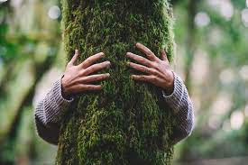
Your Pristine Truth: “The undeniable fact is this: it’s absolutely true
that you are reading these words here and now.”

Think about it for a moment. It’s your indisputable moment of truth, of self-evident proof that Youness and your 54-senses exist, are alive and belong as what you really think and feel in this spacetime moment. Isn’t it perfect? While in an attractive natural area, it’s wordless youness and Nature’s eons are a single space-time essence, your whole life in action. If youness accurately label it as “ness,” what youness 54-felt sense experience, like oneness rather than worriedness, friendness not aggravation, Natureness not depression. Pristine truthness is our “now” genetics.
Note that if a scorpion, tornado or feces could read, this Pristine Truth would unify them with all others that could read. This occurs because Pristine Truth exists in its space and time on this page, now. If these things were in some other place or moment, then it would not be available. However, it would be as soon as we/they adopted and stated it appropriately for that other time and place (space-time). That’s precisely the Natureness green switch solution we are missing.

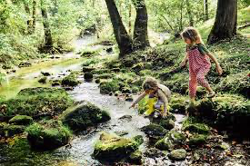

Felt senses are authentic: A selfie taken by the sense of community (sense #34)

The Natureness of Pristine Truth is like an accurate clock because it reports the facts as it’s continually updating itself so as I write it again it’s true about this new place and time on this page. In this way, “The truth is that you are reading these words here and now,” is not the same as it was above. In this moment it is truer from the additional paragraphs and images alone along with other things that have happened since you first read the statement. This means that what you/Youness may not find true in this Pristine exhibit now will become true in later exhibits. For this reason, this narrative repeats, summarizes or reviews key points whose truths, might become polluted by regressing to their earlier warps.
Selfie: sense of being part of a greater being
My truth repetition here makes the total article become an organic
spacetime fact-check, a habit-breaking force that therapeutically keeps in context and self-corrects to stay alive. You/Youness can apply and trust it anywhere, from sub-atomics to feelings to family to cosmos. For example, boldly, right now, here, the article defies the notion that there is no such thing as singular or absolute truth. This instant is one. It is absolutely true Youness are reading these words, here and now in space-time, while attached to the rest of the space-time Universe’s life.
Most people love their Pristine Truth, especially in natural areas, because, there, Natureness, Nature’s essence, helps Pristine Truth’s coalescing ways peacefully anchor folks in the happiness of their reassuring sense of trust. Their Natureness replaces their stress, fears and pain with the satisfactions of exceptionally accurate 54-sense information and its organic balance. More fully expressed your Pristine truth is: "It's an absolute fact that Nature exists, and that you exist, you are alive and heartfelt want to live. Your senses are working while you are now learning about Natureness while breathing and growing and reading these words this instant."
Sadly, most people don’t know what their Pristine Truth is because our formal and informal education and counseling make a profit by purposely omitting it. They also omit Natureness so society can control us or to sell us something to replace Natureness’s disturbing exclusion.

Felt senses are accurate: A selfie taken by the sense of domineering (sense #36)

In the reality of existential science, when needed, things that are true exist, just like this article does right now. If our words identify things and they don’t really exist, our words are pirate deceits that hurtfully mislead us. Here, via Natureness, as we continue, our Pristine Truth is spot-on indisputable and unconditional. That’s why this narrative can help us increase well-being, moment-by-moment, especially if read in conjunction with a natural area or pet or plant.
In today’s person/planet crises, whenever we do not apply Pristine Truth, as pirates we deepen the rut of our prejudicial war against Nature’s distortions and their sickening effects so our crises increase.
For this reason you learn more if you read this article while you are you/Youness, your Natureness, in contact with the absolute authenticity of an attractive natural area and add “ness” to what attracts you there. Your pet or potted plant will otherwise suffice. Then, without words, the area’s life-desire to recover will help your life and vice-versa. See if You/youness can find examples in a natural area of what the narrative describes as you read it, add ness to them, and enjoyably learn from the results
Note that atmosphere means “vapor of a planet sphere,” inspire means “bring in life-spirit (a breath of life)”, expire means “depart life-spirit,” respire means “restore life-spirit” and conspire means “breath life-spirit together.”
Note that this article consists of science with attitude. Its Natureness conspires with you and natural areas to stop our pirate stories’ prejudicial war against Nature.
Note that we are able to constructively conspire using words because our essence is always Nature’s attraction (love) to begin life and dance it. Nature loves us into unadulterated, cooperative being.
Note that as pirates we keep ourselves alive with each breath we take while our awareness omits that each breath’s source is the 13.7 billion year flowing growth of Nature and its Universe that has preceded it into, as well, wordlessly becoming this moment.

Review: Your Pristine Truth demonstrates that whenever you read it, or are aware of it, it is your space-time truth of the world in that moment. In heartfelt ways it supersedes all things because it includes every other truth that helps space-time replace our pirate lies with the benefits of the facts in any situation, except two.
- One fact is that you are not yet convinced our Pristine Truth is true.
- The other fact is some abuse you endure so that your Pristine Truth “hooks” it into your consciousness. It’s still too painful so it can’t accept its truth and history, or it warps the facts.
In summary, beyond reasonable doubt “here and now” is the scientific Natureness certainty that our Pristine Truth is genuine fact, the truth, the whole truth and nothing but the truth so help our spacetime Pristine Truth singularity that is you/Youness every moment-by-moment.

VALIDATE: At the end of each exhibit, to “conspire”, meaning “Consciously take a few deep breaths with Nature and become your Natureness” and find an example of that exhibit’s information in a natural area or pet. Then decide if the exhibit is
( ) Valuable/proceed or ( ) False/read references or (Cohen 2021)
You can change this PDF into a Word document, add your affirming experiences to it and later submit it towards your certification. You can include your reactions, drawings, photographs, poems, felt-sense selfies and the like that tend to strengthen your validation.

For example, you might add
“Seeking my true self I saw tree roots growing from a stone. This powerfully touched me. The root attraction made my heart softer, and I felt rootlets slowly deep breathe in my chest reviving my inner roots. I felt safe and confident. I am you/Youness rooting in Natureness’s love for colorfulness, surrounded by safeness. Everything health-wise, instinctive, and intuitive is deeply rooted in me/us/it."

See other examples at (Cohen, 2020d).
Selfies: In space-time all things everywhere, past, present and future, exist at once including our thoughts, senses, feelings and imagination along with reasonably expressing them. This means your Natureness can legitimately let your senses take selfies of themselves in a natural area, pet or person, and label them as such. This lets high-tech science words help each sense become a stronger Natureness fact of your life. This image, for example,

Felt senses are intelligent. A selfie taken by the sense of ecstasy (sense #53)

As a reminder to validate exhibits, the word Validate appears at the end of each exhibit. Validate
Pristine Truth Exhibit 2. In the emergency of today’s already bankrupt and broken world, in any given moment, our Pristine Truth Natureness either increases personal and global health or it’s an additional upsetting falsehood. Yes or no. No ifs ands or buts. That’s the thrust of this Natureness article. In the now, it loves to increase our/your well-being by its Pristine Truth replacing the lies of pirating words that deceive usness and it helps us help others do the same. Validate

Truth Exists

Pristine Truth Exhibit 3. An inaccuracy that we write on paper can produce major consequences when carried out in Nature’s reality. For example, a list of instructions for finding an oasis in the desert can result in the anguish of dehydration if just one instruction mistakenly says turn “right” instead of “left.” Other tragic examples are,
- “Planet Earth is an infinite rather than limited resource.”
- “We live on Planet Earth,” when actually we live in it, under its clouds and flying creatures, as part of its biosphere’s eons of growing, self-organized development.
- “The Universe is a mechanistic, static thing that decays into entropy’s disorder,” instead of “The life of our space-time Universe is its intention to grow its own space and time. That is Nature’s wordless attraction (love) to begin life and dance it into being.” Validate

Pristine Truth Exhibit 4. Nature and we exist here and now. An indisputable fact is that if Nature or we didn’t exist, our Pristine Truth Natureness couldn’t be true because we and it wouldn’t exist. This core way of knowing is the wonderful heart of pure science: at any moment for something to not-exist or exist, 0 or 1, false or true, wrong or right, on or off, guilty or innocent, dead or alive, connect or be disconnected, reliable or un-trustable, be Natureness or an anti-Natureness pirate since 1974. Cohen (2021a)
When you/Youness apply Pristine Truth to your personal life your 54-sense existence becomes an undeniable fact, so you scientifically know it, and more happily know how and who you are, what you are and do and help others do the same
This Natureness singularity removes doubt and conflict, increases resilience, creates unity and brings joy because all things hold one attractive thing in common: they have survived to this instant in reality and/or memory. This holds true even if you don’t believe it or are not attracted to existing. It’s self-evident. You/Youness must first exist to be non-attracted or a non-believer (Cohen, 2016a). Validate

Pristine Truth Exhibit 5. Your Pristine Truth Natureness is a happy sentiment that needs no proof. Being existential and empirical, it lovingly registers directly in Youness’s senses of consciousness and reason in concert with your 52 other senses (Cohen, 1995). Pristine Truth celebrates that you are alive and exist and that you know you know it. Again, you can’t know that or anything else if you don’t exist.
Our broken world and lies have so distorted our thoughts and feelings that most of us can’t answer this simple question, “What is the greatest truth in your life that you can trust and it is not Nature, God, Love or Honesty since their lies have created today’s miseries” We are born with and as our greatest Natureness Truth but we are educated to reject it. Without Natureness we suffer the lies we create. Do you know the answer to the greatest truth question? Most people don’t. That’s a key but very easily solved problem. (Cohen, 2021) Validate

Our 54-Sense Truth

Pristine Truth Exhibit 6. We don’t have to prove what we sense or feel in the moment because our life scientifically registers our Pristine Truth through the reality of self-evident sensations we directly register in our 54 senses. They are inherently sensible. You are doing this right now with these letters and their forms. By the words they create, we Pristine Truth know that we have senses of sight, reason, consciousness, literacy, color, shape, trust, community, place, distance and aliveness. Thankfully, via Natureness, these, and 43 other senses, register, blend into, validate and convey our Pristine Truth at this and any other spacetime moment (Cohen, 1997, 2016d). Omitting Natureness omits them and creates our troubles.
Note with alarm that only one of these eleven senses, the sense of sight, is one of our five senses that were identified by Aristotle circa 330 B.C. This alone tells your sense of reason it is false that you only have five senses. You simply validate that you have experienced ten more senses, including your senses of reason, consciousness and survival at this moment. Validate

Pristine Truth Exhibit 7. Reasonable relationships are a 54-sense Natureness bliss because the life-supportive climate they create is the emotional climate you live in. As you nurture them and it via Natureness, both gratefully nurture you. Validate,

Truth Is Alive

Pristine Truth Exhibit 8. Since before the Universe began, speechless Nature, has been and is its wordless attraction (love) to begin life, a love that, by 1950, was identified scientifically as space-time and became common knowledge by 1970. Your existence and growth validate this because as part of Nature, like it and everything else, moment-by-moment, including this moment, you/Youness are Nature’s spacetime continuum loving to begin your life as energy and matter in the next moment. This is far more attractive for you than not living. Via Natureness, you recognize that your life’s desires and energies are a real thing, they matter. Validate

Pristine Truth Exhibit 9. Review: our Pristine Truth is part of the here and now of Nature’s spacetime love to begin our Universe before its big bang birth. You can validate this because you are experiencing it unless you are suicidal. As a demonstration of this, bring the Pristine Exhibit here into this moment______ and note that it and its truth still exist. Validate

Pristine Truth Exhibit 10. Review: You exist and are alive as part of the life of our Universe’s love to live. It is completely logical, if not self-evident, that if Nature, the Universe, or our planet died this instant, you would also be dead. This is also true if you stop breathing. Then your Pristine Truth couldn’t be true because, being “dead,” neither you or anybody else could produce, know, speak or live it.
If Nature died, so would its wordless attraction (love) to begin life. If you/Youness know you are alive, be Natureness assured that the essence of our Universe is alive since all is one in any spacetime instant and all is Nature’s moment-by-moment attraction sequence to live and love us into being for the past 200 thousand years. It’s like we are a label-applying surfboard on the tip of Nature’s wordless wave of life. Validate

Pristine Truth Exhibit 11. As you/Youness can sense and feel, your life as Earth’s life loves to live. It wants to support and nurture life in peace so we and it can continue to live and grow. It is also true that you may fight and risk death for your life’s survival; that is your Natureness spacetime love to live in action (Cohen, 2010). Validate

Summary: thankfully, we exist, are alive and live in the life of our Universe. It consists of Nature’s spacetime love to begin life and it has been omitted from our pirate education’s felt-sense thoughts and relationships since it was validated in 1949. The fact that science and education leaders cannot yet affirm that Nature or Earth are alive demonstrates the consequences of Natureness omission. Get real, we are being misled and suffer the results.

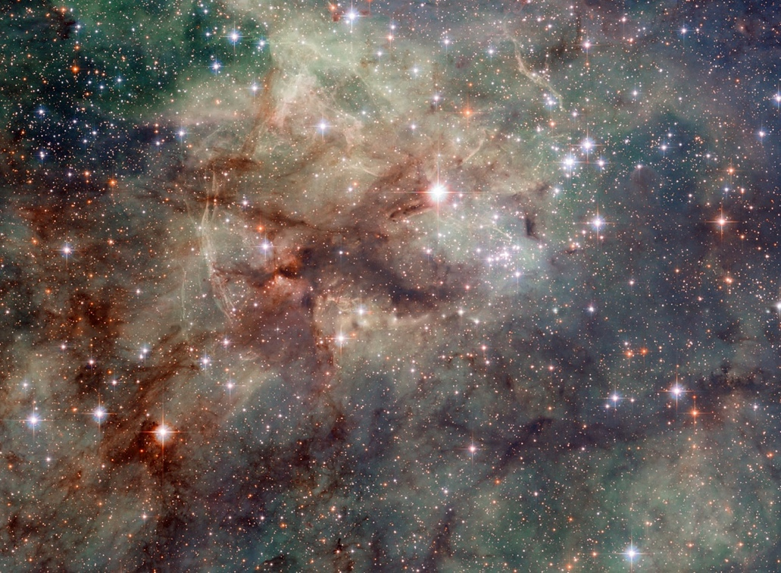
Felt senses are reality, A selfie taken by the love of love (sense #54)

Space-time Exhibits

Space-Time Facts
NOTE: from this point on “you” is understood to also mean “you/Youness” because this wonderful choice is always available

Pristine Truth Exhibit 12. Review: For the past century, scientifically we exist in the flow and growth of Nature’s space-time Universe, not in a static, mechanical Universe as was thought before 1925 A.D. until Edwin Hubble observed the galaxies expanding/growing-away from each other. Painstaking evidence since then demonstrates that our Universe has seamlessly grown, like a tree’s seed, by progressively procreating itself. This has occurred since Nature loved to give orgasmic Big Bang birth to it 13.7 billion years ago, as well as before it while it was its attraction to be born (Cohen 2022a). Because all things in its historic eons, as well as real time, are attached to each other in spacetime’s now, the essence or identity of each thing is always Natureness present as either our stories and memories, or our immediate experiences, or our thoughts about the future. All things, past and future exist in spacetime “now” as unadulterated reality energies and/or as true or false story energies.
Nature’s love to begin life now is also our subconscious life in action. You can validate this fact by thinking about this moment’s experience, and/or whatever memories, stories, facts, dreams, thoughts, things or feelings you have or will experience. Note that they are only real and available in this present moment of the Universe as your Pristine Truth because your life exists. Nobody has ever disproved this fact because that person had to exist and be alive when they tried to disprove it. Your life might enjoy reading this last statement again because it is your Pristine Truth Natureness anchor and argument. Validate

PRISTINE TRUTH SCIENCE SYNOPSIS: Nature’s wordlessly loved and grew our Big Bang Universe into spacetime-being 13.8 billion years before humanity first appears in it, along with our unique words and storytelling ability. The latter was only about 150,000 years ago. Any of our stories, information or relationships today that omit the Natureness of when all of existence historically began are pirate misrepresentations that painfully demean, abuse and polarize the world. This makes us create our wars, disorders, injustices and climate crisis. Because we have known, but ignored, this spacetime fact for 71 years, we increasingly disconnect, break our world and suffer accordingly (Cohen 2020a). We can, instead, apply the Natureness remedy for this tragedy via this article. Natureness is the single valid label for each moment Nature begins. Validate

Natureness Exhibits
Attraction is the Essence of Love

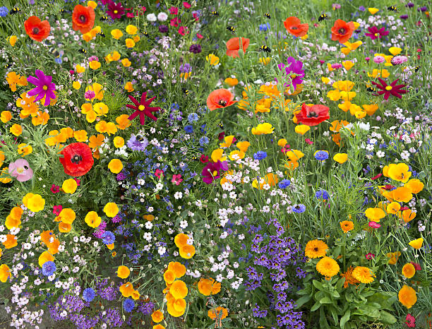
Felt senses are universal. A selfie taken by the sense of color (sense #3)

Nature’s Wordless Love

REMINDER: from this point on “you” is understood to also mean “you/Youness” because this wonderful choice is always available
Pristine Truth Exhibit 13. Apart from humanity, including you, Nature’s love to begin the life of the Universe and our Planet is non-verbal, like the Tao, a lake or a tree. Unless you can offer a scientifically valid example, no evidence exists that Nature has ever communicated in written or spoken words as we humans do. However, as this moment demonstrates, our Natureness Pristine Truth is an exception to this fact. Here and now, we are Nature’s essence using words to help us be our Pristine Truth as we walk our talk. In that way this article self-corrects and peer-reviews itself. Otherwise, words are abstract values, artifacts that we impose that restrict how Nature works since, being non-literate, it is helpless and vulnerable to our meaning of words, short term. To our loss, wordless Nature can’t constantly remind us that since Earth is presently in 75% deficit, there is no free lunch and Nature bats last as climate change and Earth Misery demonstrate (Cohen, 2001).
Since we exist and grow in and as Nature’s spacetime love to begin life, our ability to speak words is Nature’s love-to-begin-life expressing itself and its purity through our 54 senses and their labels and definitions.
We are seldom taught that the words we experience are not coming out of nowhere. They are Nature, a natural area we call Planet Earth, speaking as and through us. We either scientifically speak the words that describe Nature truthfully or they are un-trustable pirate distortions. The latter make Nature/us lie about or attack itself so Nature’s integrity painfully disintegrates, in and around us.
Our sense of reason, in concert with 53 other senses, recognizes that it is unnatural and unreasonable for us to felt-sense think or act-out words that we know injure Nature, especially since our senses of pain or fear make us aware when our excessively nature-disconnecting stories abusively inflict these injuries on our person, or nationally or globally (Cohen, 1995).
Climate Therapy’s Natureness is an existential science. When its Pristine Truth removes unreasonable stories we discover that our excessively nature-disconnected world of words is a dream. It does not exist anywhere else in Nature. When that dream is not logically organized by our reasonable 54-senses, our words make us become pirates or soldiers in our war with Nature nightmare. Validate

Pristine Truth Exhibit 14. The lies of our excessive, unscientific pirate stories and labels about Nature change Nature’s and your life into conflicted and distressing climates of nature-disconnected labels, artifacts, relationships, emotions, behaviors, beliefs and environments. Your deeper, speechless Nature subconsciously lives in continual fear of how these may further hurt or abuse you or when they will be painfully triggered into your consciousness if something “pushes your buttons” (Mallory, 2017) (Uhl, 2016). Validate

Pristine Truth Exhibit 15. Our stories and labels can instantly transform the lies and inaccuracies that create our abusive relationships into 54-sense Natureness love that begins to remedy them. You can validate this if your Pristine Truth here is doing it with respect to you increasing your trust and love of it. Validate

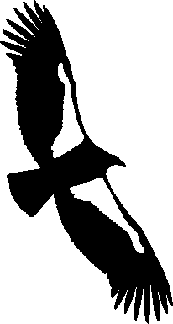 The Nature Of Attraction

Pristine Truth Exhibit 16. “Attraction” is an evidence-based label for the power that holds things together. It’s a thing, a fundamental force or “glue” that unites things, from sub-atomics to families to galaxies and beyond. This includes us at our conception and all of Nature simultaneously in the now. Nature’s wordless attraction (love) to begin life is a now attraction sequence that is attractive. Its purity doesn’t adulterate or do abusive things to itself so it produces no garbage. Repulsion is a protective sensation that reminds us to seek more attractive attractions.
You can validate that, including yourself, things exist and grow from attraction. For example, as you are attracted to continue to read this sentence you are aware of of its words, not its individual letters until I mention this now. Also you may have missed that the word “of” was doubled in the previous sentence. Isn’t it attractive to continue and know these and other omitted facts so you may not be or feel misguided or mistrustful later? If not, how do you explain that you are now at this point in this new sentence if being here is not attractive?
Attraction is spacetime motivation in action, even if its source is its desire or habit, love, pain or fear, real or remembered (Cohen, 2020). Validate

Pristine Truth Exhibit 17. In story-less Nature, attraction is free-will conscious of what it is attracted to otherwise it would not know or register what to connect or attach to. Even if you are being coerced into reading these words, It’s more attractive than the alternative, you are doing this right now with your attraction to this sentence and possibly the next one (Cohen, 2017). Are you going to follow this attraction? Validate

Pristine Truth Exhibit 18. Attraction in at least 54-sense ways organically holds all parts of Nature together, including yourself, while Nature is attracted to begin life. You can use Exhibit 6 to demonstrate this fact if your life at this moment can’t. Validate

Pristine Truth Exhibit 19. You know you love your 54-senses because your life embraces and depends upon their attractive satisfactions. That’s why you feel hurt and unhappy if they are abused, rejected or if you think some thing or disease will take them from you. Do you think you really want to get rid of any of them and their value?

Pristine Truth Exhibit 20. Because attraction draws things together, it is the essence of love and unity including Nature’s love to begin your life in this moment, and love you into being. Is there anything you are sure is not held together by attraction? Are you attracted to speak rather than not speak, to live or not live? Can you see that repulsion is actually attraction to some more attractive attraction? For example, we are not repulsed by danger, we are attracted to run for our lives to something more attractive, not towards suicide. Validate

Pristine Truth Exhibit 21. Review. Life loves to live. Attraction helps us accurately felt-sense experience and define Nature as its speechless attraction/love to become life. This organic energy holds immense or miniscule things together. There is no such thing as a vacuum or empty space because they are all filled with eons of space-time attraction energy. Scientifically, our Pristine Truth is speechless Nature’s verbalized attraction to grow as the life-flow of its space-time, Big Bang Universe this instant. It was similarly immensely attracted to birth itself as energy and matter 13.7 billion years ago, as it is attracted/loves to grow in and as spacetime here and now. This is because life loves to live as your life and mine. Validate

Pristine Truth Exhibit 22. SUMMARY Scientifically, since its beginning about 14 billion years ago, or before the flowing growth of speechless, organic Nature, moment-by-moment, has loved to more attractively give birth to the Universe and its spacetime love to live and grow, moment-by-moment (Cohen 2019a). This includes us and this article now. Over time, this attraction has grown stronger and become more attractive via homeostatic diversification. At this moment attraction continues to diversely grow everything in the Universe including Planet Earth you and me, to be more attractive, to attract more love. You, I and these words are it in this instant.
Pinch yourself. You can Pristine Truth sense the pinch and your existing life. Look around. It is self-evident that it, the world, and you exist, live and grow simultaneously. Isn’t that survival, including yourself, attractive? Note, however, that you can speak words that assign specific meaning to things and Nature can’t do this. To Nature, speech is foreign, an "abstraction," meaning “to draw away from or disassociate.” Without Natureness, Nature’s love is defenseless against our non-supportive pirate words about it. That is the core of our war, disunity and abusive climates.
Spacetime research since 1925 affirms that the Universe’s life is not stop-time static. It has an attractive direction and purpose as its beauty demonstrates. Its space-time sequence loves to support and grow its life. Nature’s attractive intention is to continuously begin pure spacetime life, where all attractive things, including Pristine Truth, exist harmoniously and unconditionally. This is our 54-sense attraction to well-being. If you can’t feel that love this instant, to validate it, try disconnecting from its atmosphereness. Hold your breath. You’ll felt-sense your organic love to live it shortly. Validate

Nature’s Singular Sequence

Pristine Truth Exhibit 23. Review: In storyless Nature, attraction is free-will conscious of what it is attracted to (Cohen 2017). That is the essence of love and unity including Nature’s love to begin your life in this moment. In spacetime, anything you are conscious of always materializes after and from that same thing’s preceding moment. During this organic transition and while attached to their origins (homeostasis), new attractions (diversities) establish their attractive lives.
When the review, above, is communicated in industrial society, scientifically our Natureness words consciously symbolize Nature’s attraction to wordlessly continue spacetime’s life-as-matter, math/science sequence (Cohen, 2017). As part of Nature’s love to begin life now, this sequence is also who, what, where, when, why and how are you: You are Nature speaking your love to begin life. So am I and everybody else while the natural world does it wordlessly.
THE SEQUENCE: As per Exhibits 1-22, above, in this instant that is our Standard Universe story, all things are simultaneously living out our Pristine Truth’s
1) Love to become our wordless Universe of 14 billion years ago,
2) Love to birth and become the now of our wordless, growing, Big Bang, energy-matter, spacetime Universe of 13.7 billion years ago.
3) Love to instantly become our wordless unifying attraction field as gluons, Higgs boson, gravity, electromagnetism, strong force et al. (Cohen, 2012)
4) Love to become our 13.7 billion year continuum of wordless, attractive spacetime growth and diversification in unified, homeostatic balance.
5. Then 150,000 years ago our complex language develops. We love to become humanity’s true or false words that, for survival, prejudicially override and hide knowing ourselves as Nature speaking its/our love to become life. We attach to a unique “pirate story” world that we invent is attracted to Nature’s love of life as a resource. It is a protective but often misleading love that bonds us to be artificial and profit as we wander into less supportive climates and environments.
6) Love to become our inaccurate pirate words that say “The Universe is mechanical.” That story claims, that like a throw of the dice, we evolve by probability selections as we decay into the disassembled chaos of death and entropy. It says that when a thing’s love to begin life dies it is recycled and restored anew. This meant, incorrectly, that Earth is an infinite, ever-replenishing resource that our nature-disconnecting words can prejudicially abuse, conquer and exploit indefinitely without harming Nature.
7) In 1949, after 46 years of research, quietly, our evidence-based words and reasoning replaced the Mechanistic Universe story with today’s life of our Universe space-time science. It is nature’s/our continual love to begin and grow pure life.
Our pirate stories are inaccurate when they excessively nature-deprive us so we omit Gaia, pre-humanity’s wordless 13.7 billion year life-flow of our Universe’s Pristine Truth, existence. It’s space-time life discloses the destructive falseness of pirate stories about Nature, God, Love and Honesty, especially since they omit Natureness and Pristine Truth as they fuel our prejudicial war against Nature.
This sequence is like Carl Sagan’s “If you want to create an apple pie from scratch you must first invent the Universe.’ Your Pristine Truth life with words invents the Universe because you are a personification of it that can speak. You inherently know it loved you into becoming you as Big Bang space-time, at your conception and this instant. This explains the discovery of how and why every 5-7 years every atom in your body is mutually-beneficial loved to be replaced by a renewing atom from the natural world and vice-versa.…………………………………………..
Visit Exhibit 23A at www.exopsych.com/NATSPIRAL.pdf Validate
Nature’s Love To Live

Pristine Truth Exhibit 24. Our 54 felt-sense thoughts and relationships painfully signal when they are abused by our lies hurtfully breaking-up our Gaian love-to-live around, in and as us. Out of pain, fear or reason this abuse attracts our 54-senses to seek more attractive things and relationships to satisfy this loss of love. We call this base feeling “survival” our desire to keep Nature loving to more attractively become our life in the now of spacetime. For example, the immediate pain of a hot stove attracts your finger to a more attractive cool place so it survives rather than burns away. Validate

Pristine Truth Exhibit 25. Review: Nature constantly loves to become the aliveness of its “now” space and time climate that it creates and where (space) it resides every instant (time). This means that, in spacetime now, all the essence of the Universe and its eons of growth are Nature’s spacetime life becoming your Pristine Truth, “You are reading these words here and now.” As aforementioned, this makes you an attractive, special, personification of spacetime that can speak. It enables you to register and accurately label your whole-life unity as your deepest Pristine Truth love of life to live and grow. In imagination or reality your first or last name could be “Spacetime.” It’s your conscious and subconscious life in this moment. Do you want to give up your spacetime life or make it more attractive and healthier? Validate

Felt senses have integrity. A selfie taken by the sense of companionship (sense #35)

Natureness Great Truth Exhibits

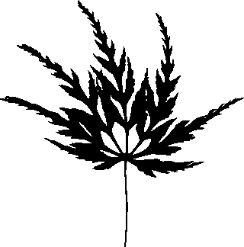Words Are Not Reality

Pristine Truth Exhibit 26. Your Pristine Truth includes that rarely does the story of an article stop the falsehoods its story identifies so things seldom change without additional acts, conflicts or fights. This article remedies that phenomenon by blending the information in all 1-25 Pristine Truth exhibits to create and strengthen a unifying Natureness great Truth of your life that you can trust. This Natureness is not Nature, God, Love or Honesty because, since they are only geologically recently invented by our words and concepts, their meaning omits Nature’s previous 14 billion years of space-time’s wordless attraction (love) to begin life. It’s like we have had the Universe surgically removed from our mentality so we think and relate like it never grew or exists and we suffer accordingly. That’s our untruth or sin of omission as per Exhibits 12 and 23.
Without our Natureness, the present is adulterated by past falsehoods. Once you know your Natureness, you help stop our Natureness distortions from breaking the world into our personal and global earth miseries.

Earth Misery Climates: due to our prejudicial war against Nature’s web-of-life (Cohen 2008), this year, 2021, on average, we and our living planet endure a steadily increasing 45%-75% loss of its recycling, composting and healing powers (Global, 2021). These vitalities are located in Earth’s eons of attraction-based wildlife and natural resources growing harmoniously in the now as part of Earth’s metabolism.
This alarming natural resource deficit is accompanied by a parallel 45% increase in our mental illness, obesity, climate change, oceanic oxygen depletion, loneliness, atmospheric carbon warming, mass shootings and excessive stress.
Earth Misery Climates’ painful outcomes increase corruption, child abuse, unhappiness, mistrust, unfairness, political and economic extremes, destructive cravings, dependencies, addictions and many other ailments. Most are earlier abuse being space-time reactivated.
Our Earth Misery Climates socialize us, on average, to live 99% of our lives out of tune with our Natureness love and spend 95% of our time indoors (Klepeis, 2001) (Weir, 2020).

As exemplified by the additional value you find in each Pristine Truth exhibit here, your Natureness can instantly discover, fortify and actualize Pristine Truth in the now of anywhere, any place, anytime because then it is real there, not just written words here. This makes the remaining exhibits here be Natureness exhibits that pertain to Earth Misery Climates and spacetime everywhere, not just the Pristine Truth in this article.
For example, you will learn that if you visit somewhere next week, you can take your Pristine Truth as your Natureness with you and apply it to your relationships in real time there as needed. This love is an immunity that protects you from abusive Earth Misery Climates that may exist there, and immerses you in the organic joy of Natureness sanity.
In short, once you know what your Natureness Truth is, by validating and actualizing your Pristine Truth anywhere, your Natureness increasingly strengthens and Earth Misery Climates diminish.
It’s like you as pirate or ecozombie always carry an organic Natureness, green switch spray, serum or wand in your pocket. You are applying it now as you continue to learn more about your Natureness on this page. Note that when you don’t apply it you are victimized by Earth Misery Climates while their prejudicial lie of “Natureness Truth omission” bewilders you by lies that say you are not a victim of that lie. Validate

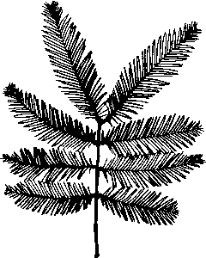 Our Greatest Trustable Truth (Natureness)

Natureness Exhibit 27. Review: The attraction-based ways Nature consciously loved us, as verbal humanity, to begin living in and as Planet Earth, started about 150,000 years ago (Boyd, 2017). However, now, as then, we alone, not speechless Nature, invent stories, true or false, that we use to guide us for our survival. These stories may verbally connect to, or repulse, each other, especially when written so they can’t easily change. Their messages often disconnect us from Nature’s wordless attraction (love) to become life as it thrives in a natural area.
We are personally Earth Misery disconnected from natural areas because we know them verbally while Nature’s love remains non-verbal i.e. “53-sense speechless, dumb or ignorant around in and as us.” Sadly, and to our loss, thing-by-thing we excessively treat or abuse Nature/us as our plaything or whipping boy because, being dumb, and while in pain Nature can’t tell us “Stop,” or send us a legal restraining order to desist from conquering or “improving” it, especially since our prejudice gives Nature no legal rights. To avoid this pain, we remove labels or relationships that can trigger it. That leaves our hurtful contacts hidden within us. We call it our subconscious or solastolgia and organize our lives to avoid experiencing it again while books and media safely vent it through their stories about it including jokes, films and competitive games as well as unreasonable drugs and behaviors. Our 54-sense attachments to our replacements for Nature’s 54-sense love hide our Natureness remedy from us so our prejudicial war with Nature continues around and in us. For example, Elton John said that his childhood traumas can still control him and, in addition to shaping his parenting style, they can make him erupt in anger without warning. It all continues to exist in the now until Natureness transforms it into love. Validate

Prejudice Against Nature

Natureness Exhibit 28. Review: When I began this article, my Natureness insisted that it be founded on its Pristine Truth so its authenticity could help me write it and be accurate. Without our Natureness playing this role, this and most other pirate writing or speech is excessively disconnected from wordless Nature’s love to become pure life in natural areas that includes weeds, bugs and swamps (The opposite of “swamps” like Washington D.C.). By omitting our Natureness, our written laws can’t stop us from telling stories, be they reasonable or harmful. (Cohen, 2011a).
Our Pristine Truth demonstrates that most of our words are limiting terms, invasive prejudiced foreigners, artifacts that war with Nature, eviscerate Earth and turn things into money. For example, as pirates our written, prejudiced against nature history includes felt sense knowing Nature as savage, barbaric and frightening, as something science must conquer to support our economics. Even after Osborne’s and Vogt’s 1949 bestselling books, (Cohen 2020a), our leader’s words have socialized us to painfully break our world into Earth Misery Climates. As our Pristine Truth’s increasing value in this article demonstrates, we can invoke our Natureness, reduce our prejudicial war Earth Misery Climates and increase well-being when we know how to apply our Natureness anywhere. Validate

Natureness Exhibit 29. Our ancestors migrated from our mutually beneficial tropical origins into foreign seasonal climates. To survive in the latter our words and leaders “improved” temperate and arctic areas so that they imitated warm tropical life. Parts of humanity survived anywhere by their stories creating tools, artifacts stories and customs that, without Natureness, rudely labeled and exploited Nature, around and in us. This birthed and encouraged us to build our unchecked indoor world closet of agriculture, heat, shelter, false and mystical stories, food preservation and medicines while it prejudiced us against nature as our enemy to be conquered. (Cohen, 1983).
Only our Natureness , right now, creates this article’s reasonable, 54-sense translation of our stories so that in a natural area, devoid of prejudice, you may peacefully unite your painful estrangement from Nature’s love to begin life, in a more satisfying and balanced way, as described below. Your Natureness is like you are feeling very thirsty and finally have the satisfactions of a natural area to be a non-toxic liquid that quenches thirst. This becomes the latest entry into your life-experience autobiography (Cohen, 2019). Validate

Felt senses are spirit. A selfie taken by the sense of play (sense #29)

Natureness in Action Exhibits

Climate Therapy’s Fundamental

Natureness Exhibit 30. Here is the inspiring Natureness secret remedy that reconnects our stories’ abusive separation from Nature’s nameless but restorative love in a natural area. (Cohen, 2016c).
As spacetime, our Natureness knows that a natural area is also our subconscious and that everything there in authentic Nature, including us, is real, universal aliveness that corrects itself as it continually begins life.
Nature’s love to begin life is at least two verbs, loving and beginning. The words for life are also verbs, its attraction or loving or desiring for living or surviving.
Our civilization teaches us that we are the stability of nouns, for example, you are your name. We are also stabilized to the meaning of the labels our nouns attach to otherwise wild natural things. For example the life of a tree is labeled “board feet.”
The Nature-foreign meaning and power we assign to our noun labels gives us word and story control over the things that nouns name. This is because we relate to things’ names, not to their Natureness, (their natural, nameless, spacetime love essence to live organic attraction relationships: NNIAAL) (Cohen, 1999).
Everything is in transition in Nature, however, things’ names usually stay the same. This separates us from Nature’s unity and becomes, instead, argumentative cubbyholes of knowledge. Our thoughts can make “Bambi,” or each other into the terror of becoming a corpse, abused or conquered so our Pristine Truth natural freedom is wounded or limited.
HOWEVER
Our Natureness can make any noun a verb simply by adding “ing” to it just as it added ness to it to identify its essence. Ing is action, a state of being space-time. For example, I, Mike, am also me Miking. Similarly, a tree is treeing, a cloud is clouding and Natureness is us Naturenessing.
NOTE: This is identical to adding “Ness” to things but is more real in that “being” is our existential now identity since we are our aliveness doing it in the space-time moment. Ness is an essence-wholeness tool to identify “Truthingness.”
Even in an injured natural area our Natureness can add “ing” to anything, so we know that thing as a living verb and vice-versa. This makes Nature literate through us in that its loving to begin life can sense how that ing label makes us feel and act like Nature’s equal and friend, not a conquering, foreign-power noun. This is like creating a common denominator for different fractions to unify in their oneness, in this case, unifying with Nature’s love to begin life in a natural area. With joy there, that spacetime love reduces our subconscious pain of disconnection from it’s source, Nature’s love to begin/grow life.

“Inging” enables your Natureness to recognize a “thing” to be an attractive, supported, free and unified part of a natural area that your words, especially nouns, have enslaved to fight our prejudicial war against Nature and the hostile climates it creates. (Note that a thing consists of the letters th before ing and that its original meaning was to assemble i.e. unify.) As your words coerce a natural thing to become an Earth Misery Climate, you simultaneously, but not necessarily consciously, also do it to its existence in and as you.

For us to Natureness, or not to Natureness, that is the question. Since 1974, to not-Natureness continues the Earth Misery Climates’ lies that break and hurtfully cubbyhole us and our world. Our Natureness breaks our addiction to pirating, moment-by-moment,
Naturenessing a natural area changes objective nouns back into loving-to-become-life verbs, including us. This makes our Natureness stronger as it makes time and space for Nature to 54-sense compost and recycle our painfully misguided thoughts and acts into its love to begin pure life fairly, as only it can do. This makes any 5-sense relationship into 54-sense bonding that becomes 850% more effective in a good way. All things breathe together as their in-common Natureness rather than be victims of pirating and its Earth Misery Climates. This produces the sanity of personal, social and environmental justice. Add it to any relationship. Be happy. Conspire! (Breathe together).
As I promised, your Natureness works, by updating your Pristine Truth “Youness are reading these words here and now” into what you experience anywhere else, especially in authentic Nature.
- For example, if your essence, “youness” loves a Rose for its color and fragrance, you substitute “You” with Youing, enjoying words with Roseing’s coloring and fragranceing here and now.” (Translation: you love a rose’s color and fragrance.)
-The Pristine Truth becomes your Natureness “Youing are loving a rosing’s coloring and fragrancing here and now” to be the Natureness of your life that you can trust and it’s not Nature, God, Love or Honesty that right now, by omitting your Natureness, continue to pirate our world into Earth Misery Climates.
In this spacetime reality, Pristine Truth “inging” 54-sense transforms what ails you into a rewarding, safe and scientifically reasonable spacetime platform or lifeboat that, at will, your Natureness can return to in reality or imagination, and reestablish in the now. Then you can continue your love to live while your Natureness platform consciously embraces you in your 14-billion-year history of Nature’s love to begin life rather than the stressful prejudice of Earth Misery Climates. That love to support life and grow is a wonderful and wise purity that you personify and can experience and share with others, especially if you are in a natural area.
Although this process seems complex and lengthy as you read it, you can achieve it in less than a minute by being your Natureness in a natural area and inviting an attraction there to respond to “Youing would love consent from ‘Roseing’ to learn from it in mutually beneficial ways (Cohen, 1990).” Once you obtain that consent, in three minutes, you can completely update and actualize Carl Sagan’s famous apple pie statement to say, “If you want to create well-being from scratch you must first invent Nature in a natural area.”
In the now, our Natureness lets our Pristine Truth label and speak the Tao as well as actualize Confucius’s “The beginning of wisdom is to call things by their right name.” Without their Natureness, since 600 BC, Buddha and Thale’s deductive science have preached against, but actually created and supported, Earth Misery Climates.

Practice your Natureness

- For 5 minutes, youness go to an attractive natural area and with each thing Youing (your name with an ing) recognize there, a tree (or anything else that’s attractive), and label it an ing, like treeing. Think about the truth of Youing and treeing both being Nature loving to begin life in that moment. Then say to the tree “Right now treeing and Youing are Nature loving us to begin our lives together.
- Now, in imagination become the treeing, and you say to Youing, “We are Nature loving us to begin our lives together,” and discover what is valuable in doing this.
then
- For five or more minutes, 54-sense how many attractive things about treeing you can find that are as parts of Youing. In actuality, they all are except stories that say they are not.
- Then, become treeing and see how many attractive parts of Youing it recognizes being treeing. In actuality, they all are except your stories that say they are not. (Cohen, 1989).

This activity helps you find Natureness support for your life and where you may work on reconnecting the stories that say they are not parts of Naturing and may be misleading you.

The core of a natural areaing becomes the common denominator “All things here are their love to live by supporting this area’s spacetime love to begin life now.” Our lies are the words in these disastrous times that prevent our Natureness from actualizing our Pristine Truth happiness while transitioning off this page and into other realities including stressful interpersonal relationships.
NOTE: Only if you know your Natureness, can this exhibit be used to reduce the excessive separation of Nature’s and our essence. For example, by adding “ness” instead of “ing” to things, like treeness, or calling things people, like tree-person or rock-person, or “non-verbal me,” or “loving to begin life.” Via our Natureness, these inging substitutes when added to relationships, human or otherwise, help increase the well-being of our personal and global climate as they transform Earth Misery Climates into Nature’s unconditional love to live by beginning life. Then all things belong and mutually support and balance each other for survival as authentic Nature’s love. While you do this your stress and disorder symptoms disappear because you have unified the conflict that created them. As doing this becomes more habitual and important your well-being similarly increases. Without Natureness our thinking and relationships continually deepen the rut we have created as they reinforce the lies of omission that produce Earth Misery Climates. Earth Misery negates that in Nature’s “survival of the fittest,” the fittest are things whose attractions most cooperatively support other thing’s attractions or attractiveness.
Inging makes your Natureness therapeutically become the Lorax or an Earth Avatar so you can speak and act to make spacetime in Earth Misery Climates for Nature’s love to do only what it can do. This process, called “Grokking,” is a relationship that helps some of your 54 senses green-hug an attraction in a natural area to blend with you and others, and vice versa, so you become felt-sense oneness, personally and globally (Cohen, 2016a). Grokking is your crucial Natureness antidote for Earth Misery Climates. Interpersonally, its singularity “cures” the bi-polar, schizophrenic and prejudicial, along with other disorders, because all things become one natureloving.
Inging demonstrates why a natural area’s peace and unity are a Natureness “Higher Power.” These “space-time actualizations” don’t produce garbage, war or undue abuse while they constantly become optimums of life, diversity, love, community, trust, balance and cooperation (Cohen, 2007). This explains our omitted Natureness’s, ever-increasing, mistrust, conflicts, injustices, lies, divorces and Earth Misery Climates.
Here’s a corrective lens for your worldview: Without our Natureness most of our words insensitively abuse Nature’s love around and as us and we react accordingly.

In summary, without our Natureness, you and I learn to know and relate to Nature, around, in and as us, by restricting the natural attractions of “things” as we label their wildness with words that they are not. We control and manage them as conquest-driven labels and stories dictate. In turn, our emotions and intelligence, including our 54-senses, protest their loss of Nature’s love, fairness and freedom.
To stop this invasive injustice, our Natureness injects Pristine Truth into Earth Misery Climates. There, its Natureness “inging” in natural areas makes the labels accurate, free, attraction-loving verbs that we and Nature’s love hold in common to begin life. Sharing this with another person is especially valuable and builds lasting reasonable relationships between people as well a Nature. Any personal, social or environmental cause that omits their Natureness is 850% less effective and more destructive than needs be.
When you improve life by inging, something soon happens in a good way, meaning to the benefit of all. Quiet time in a natural area automatically makes this connection on a personal or local level, but without your Natureness seldom in a lasting or global way.
Have you ever felt a special peaceful happiness in a silent (wordless) natural area? Was it valuable? Different than being in a shopping mall? That joy was Nature’s love rewarding your senses for sensing it.
Many studies show that Nature-contact increases a person’s well-being (Cohen 2015). In a natural area it improves person/planet well-being 850% better if you are youness. Then Natureness’s momentous, safe, spacetime switches on a healing and unifying happiness energy.
In the now, all things become the perfection of Nature’s love to procreate life’s purity, balance and beauty. During these green-hug moments, Earth Misery Climates don’t exist while, unimpeded, person and planet well-being increases and becomes a spacetime platform for our love of life to continue by beginning again in the next moment.
Note that most spiritual leaders met their Gods in a natural area while they were scientifically unaware that 14 billion years earlier spacetime Pristine Truth was already becoming that area’s, and their life and existence. For this reason, these leader’s truths were/are, lies that omit Pristine Truth. Without the science of Natureness or Godness, so do God, Nature, Love Honesty and us, mislead us today,
“Inging” enables your Natureness to do what my Natureness sometimes does in a natural area where all things exist simultaneously including our past stories and influential people. There, by adding ness or ing to their name, I can teach spacetime Natureness science to the nature-connected experiences of
- Buddha, -Jesus, -Mohammad, -Moses, -Krishna, -Betty Frieden,
- Gandhi, -Martin Luther King, -Sojourner Truth, -Einstein,
-George Washington, -Susan B. Anthony, -Hitler, -Sweitzer,
-George Floyd, -Shakespeare, -Rudolf Steiner, -Aldo Leopold.
With me they learn to update our mechanical dead Universe model of 3,000 years ago to 1925-1970 A.D. space-time life. That is approximately when spacetime’s flow and growth became the standard space-time Universe model in today’s high tech society. These leader’s truths are attracted to my assertion that our society denies it is prejudiced against nature and the remedy for this tragedy is familiarity with the Natureness of natural areas. There, they and we exist harmoniously in the now of Nature’s verbally expressed love to begin lifeness.
Your Natureness recognizes that when you find something attractive in a natural area, simultaneously it’s that same thing, in/as you, telling you that your story has excessively disconnected you from your in-common existence with that natural area and attractive thing now. The attraction signals you to reconnect, to 54-sensing it and enjoy the peace, happiness and well-being your wordsmithing has actualized by unifying our broken world’s Earth Misery separations. This strong attraction in Nature helps you happily resolve a conflict you presently endure. Similarly, in World War II the solidarity of making victory gardens quickly solved food shortages to save our nation’s life as did blacking-out our windows at night.
Do you recognize that since you began reading this narrative your you/Youness has beneficially increased your competence in strengthening it along with your ability to help others do the same while reducing Earth Misery Climates. That progress is self-evident and you can add that skill to your livelihood. It is the best proof that you can increase personal, social and environmental well-being now and in the future. If your capability has not strengthened, it suggests that you may not yet fully know your Natureness and that it’s readily available (Cohen, 2021). Validate
Note: There are 150 additional partnering-happiness activities available that, like inging, help you help Nature’s life begin to remedy our conflicts and diorders (Cohen, 1993, 1994).

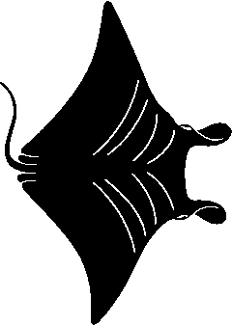 Actualizing Your Natureness

Natureness Exhibit 31. As if a miracle our Natureness lets us know what’s true by making Pristine Truth work everywhere with anything anytime. We create this “absolute organic truth” by blending of all the exhibits to create, in metaphor, a pair of spacetime, 54-sense Natureness glasses. When we put on these corrective lenses, they make anything we see or know anywhere the same Natureness of “You are reading these words here and now.”
Our Natureness glasses update our Pristine Truth while off this page and involved in anything else as long as we know what our Natureness truth is. Most of us don’t but we can learn it in seven minutes by phone and then teach it to others. (Cohen, 2021).
The glasses have two different lenses, one with our Natureness and the other our Earth Misery Climate perceptions. That is how in reality and imagination our glasses activate our sense of reason so we can act more sensibly, especially because Natureness glasses inherently know that Nature bats last (Cohen, 2011).

OPTIONAL: A means to strengthen our glasses is the acronym “NNIAAL-54.” It quickly brings to spacetime awareness our Pristine Truth’s 54-sense, Now, Nameless, Intelligent, Alive, Attraction Love that, without our Natureness, becomes today’s lies and Earth Misery Climates. Your Natureness glasses can NNIAAL-54 anywhere because anywhere always contains Nature’s continual love to begin life in pure spacetime while the prejudice of our Earth Misery Climates deteriorate it (Cohen, 1990).

Do you recognize that “You are reading these words here and now,” has become your mobile Natureness glasses that work anyplace you know what you Natureness is? Nature’s love and your Pristine Truth want you to use these glasses to make safe space for them to live. Sometimes saying “Youing” before you do something puts these glasses on. Calling yourself by your ness name also accomplishes this.
Like DNA testing can today disclose facts that were missing thirty years ago, what follows are Natureness facts I have validated by discovering and exploring my Natureness since 1936 and applying it since 1965. Your challenge is that without knowing your Natureness you are reading these words right now while they may be hiding your Natureness from you. Validating helps correct that.
Every relationship includes Nature’s love as a participant. When it’s buried alive in us we create Earth Misery Climates. Only Nature can remedy this predicament while wearing our Natureness glasses makes a safe space for its love to begin doing it. Validate
In summary, today, a 54-sense Natureness glasses remedy in natural areas enables us to take our abusive Earth Misery Climates that we create with mislabeled nouns and this instant transform them into the joy and healing ways of nature-connecting verbs that make space for Nature’s pure love to begin life now and love us into being. Validate

Felt senses are forthright A selfie taken by sense of mind & consciousness (sense 43)

Natureness Reality Exhibits

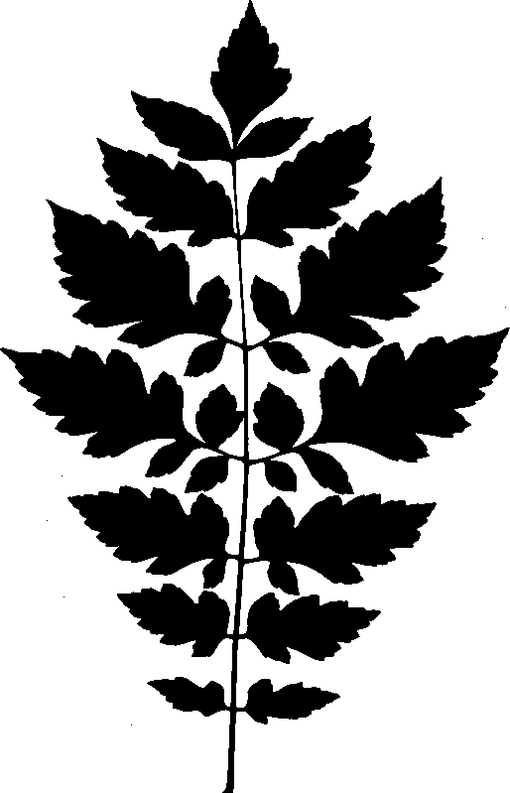Imagination Exists

Natureness Exhibit 32. Review: organic, 54-sense Natureness arts and science can create terms, stories and activities that help us produce attractive connections with Nature that are therapeutic. In a natural area this helps remedy what ails us as our Natureness begins to attach accurate names, including “ing” to things there including us.
Remember, in spacetime, imagination is real, it exists as such so there is no such thing as imaginary fear; its source is always present real time or in memory. This means that in a natural area our Natureness can take today’s prejudicial war against Nature back to our origins 150,000 years ago and our words, then and there, capturing and placing questionable labels on Nature including people right now. This lets our immediate Natureness reconnect our prejudicial nature-disconnecting stories to their peaceful origins as Nature loving them and us into spacetime being, then and now, since they are the same. This reality creates a now, reduced abuse moments platform where we can finally begin our excellent childhood.
This exhibit shows how our natural area Natureness immediately stops our hurtful conflicts rather than supporting or increasing them. It actualizes our 54-senses while they are connected to how Nature’s love works in a natural area. This blend eliminates the cause and effects of our tragic Earth Misery Climate disconnections. It enables our spacetime, in reality and imagination, to start to grow in this new, begin-life-now climate instead of remaining disconnected and victimized by nature-disconnected adverse side effects. This Natureness phenomenon can be added to anything (Cohen, 1989). Validate

Natureness Exhibit 33. All these exhibits make it imperative that we add Natureness to whatever our cause or intent if we want to halt our world-breaking Earth Misery war. If we did this, I have demonstrated that the results we want can be achieved 850% faster and stronger because Nature around and as us becomes our ally rather than our victim. For example, in our Natureness expedition community, three individuals got strep throat and because it was scientifically reasonable, the whole community agreed to change the schedule and take preventative measures while the three were treated for it in personalized ways. It was cured and never spread (Cohen, 2012).
Without our Natureness, no matter how nature friendly our activities, intentions and relationships, since 1974 we have known that our Earth Misery Climates daily increase. Because we don’t add Natureness to our relationships they are 14 billion year outdated and hurtful misrepresentations. (Global 2021). Validate

Earth Misery Climates Data

Natureness Exhibit 34. Additional Earth Misery Climates information: Our Natureness shows that we are engaged in a prejudicial war against Nature that educates us to create today’s suicidal world while violating our moral, ethical and legal rights to life (Cohen, 2016). We must hook up with another planet half Earth’s size to replenish these losses and we can’t find that planet no less know how to hook up with it. We can, however, invoke our Natureness to stop this madness.
Tragically, without our Natureness and its anti-lie powers, by law we spend 18,000 childhood hours being educated to produce our Earth Misery Climates. We spend less than 12 hours of our lifetime in tune with Nature’s love to begin life. Adding 54-sense Natureness to everything we learn or do helps remedy this dilemma. This article accomplishes that because my Naturenessing is writing these words in spacetime and my greatest trustable truth is also everybody else’s Natureness. This lets us Pristine Truth co-mentor each other when we know our Natureness.
Our Natureness works anywhere because it is experiential, it strengthens-by-doing so it self-corrects and improves itself every time we invoke it. While its absence creates and deepens our Earth Misery rut, its presence replaces it with Nature’s continual love to begin pure life as only it can. Validate

Maverick Genius

Natureness Exhibit 35. I discovered my Natureness when it helped me notice its existence. This has continually occurred over the 56 years I have been researching the arts and science of holistic education, counseling and healing with Nature while camping out in 84 different natural area habitats, backyard or backcountry. Since 1959 my Natureness has stated: “As a twig is bent so grows the tree and this explains why humanity has lost its way. Our growth from the ‘savage’ does not necessarily lead to the cluttered, materialistic often desperate life that we presently live. To find the right road my Natureness nature-connected learning program must return its participants and itself in reality as well as in imagination to the origins. From their essence we can go forward again in a truly civilized, not a merely artificial, way of life.”
In 1965, out of frustration and curiosity, in the bowels of the Grand Canyon Wilderness in Arizona I reasonably asked Planet Earth how its life was different from mine After I continually deducted the similarities, it became apparent. I could speak and think with words and it could not. This was self-evident, a Natureness fact because that’s exactly what was happening then. It’s happening now, too, in your Natureness now, wherever and whenever.
My decades of individuals and communities beneficially actualizing our Natureness relationships in natural areas qualified me for doctoral degrees and being recognized as a maverick genius who created accredited programs to this end (Cohen, 1998; Hoke, 2015)

I’ll match the Natureness of my 56 years of pure, 54-sense experiences in natural areas with any individual, dead or alive, and I’ll come out far more accurate and practical with respect to increasing personal, social and environmental well-being. This is because my Natureness spacetime science was unavailable to anybody before 1950 so what others did is scientifically outdated and detrimental in today’s Earth Misery Climates disaster if Natureness is not added to it. Better still, I can teach folks how to become a 54-sense Natureness maverick genius so they can help themselves and others reverse our Earth Misery Climates and their abusive ways. I have established Natureness trainings, courses and degrees to this end (Cohen, 1994, 2019).
One need not be a maverick, [read “inconvenient”], genius to recognize that all our knowledge media and experts have brought us to create, increase and suffer this moment’s Earth Misery Climates. This shameful unreasonableness continues to grow because, moment by moment, we are emotionally rewarded, no less paid money and profit, from Earth Miseries’ destructive thoughts, feelings and relationships. It’s like overeating to satisfy the loss of love you feel from being overweight. Validate

Our Warped Ego

Natureness Exhibit 36. Our Ego is our central story about us and itself. It describes who we are and our self-worth as a reasonable thinker and doer, individually and collectively. What influences our Ego often modifies how we think and grow. However, with respect to its egotistical story, it is an eye that can see the world but can’t see itself. (Cohen, 2020a)
Nature, being wordless, has no ego story. Its senses of reason and consciousness in congress with 52 other senses are its ego, moment-by-moment. Neglectfully, our Ego defensively hides its guilt for creating or participating in the anti-nature and illegal Earth Misery we create (Cohen, 2001).
Our Ego became its/our "civilized" description about how Nature should work for our survival above all because our lies convinced our ego that it is king of the world. Nature’s love couldn’t argue with that since it couldn’t and can’t speak.
When our stories omit our Natureness they are scientifically outdated or inaccurate and we suffer from our Ego's need to be rewarded as “right” as well as endure its painful disgrace for being wrong while aware the Earth Misery Climates we create are criminal negligence (Cohen, 2016). This shames and frightens our ego so it denies its responsibility for it.
Earth Misery Climates make us overuse our planet’s life to excessively produce material satisfactions for our disconnection pain. We mislabel this phenomenon “greed” instead of “Natureness Deficiency.” Devoid of our Natureness our ego mislabels Nature’s wonderful attributes to be “the human spirit,” and says Nature must be improved or conquered. This prejudice defames Nature and violates our rights to life so, without Natureness, all forms of justice are 850% ineffective.
To stop this insanity, our Natureness must applaud and reward our ego when it is Natureness reasonable and reject its non-Natureness stories for their negative outcomes while we offer them the therapeutic satisfactions of Natureness that they desperately need. That’s like creating eternal stem-cell therapy everywhere. Validate

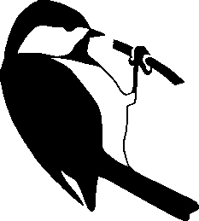 Organic Validations

Natureness Exhibit 37. In case you don’t fully trust your senses, the Natureness facts I present here have been peer reviewed and published in other scientific journals (Cohen, 1993, 2017). Our Natureness includes the science of deductive reasoning that deducts from Nature, outdated or unproveable phenomena, including the mystical and supernatural. This makes what remains trustable, repeatable, evidence-based fact. Even the billion-year-old slime mold with no nervous system is Natureness deductive and can solve some of todays advanced mazes and scientific challenges. (Cohen, 2018).
We sometimes know Nature as a wonderful experience, like an amazing rainbow, but seldom as our Natureness. This makes Nature “recreation” while omitting that it’s simultaneously re-creation, an antidote for our prejudicial Earth Misery Climates (Cohen, 2022).
Can our Natureness-omitted remedies for Earth Misery Climates ever succeed if their unjust and toxic “side effects” continue to bond us to use more goods and energies than Earth’s life can replace even as we transition?

“What was really cool was I gave my sister simple instructions of asking permission of a natural area and then asking what her Natureness is. She had a similar experience to mine, of the timelessness of her past and present as one in the now (Cohen, 2020d). It was really cool! Our child natures were attracted to this experience, and we were jumping up and down like kids and not women in our 6th decade of life! Wheee! ”
~ Natureness participant interaction

“I went to a natural area I was attracted to and asked permission to 54-sense unify with it. I asked what my Natureness is at this time and had an experience of nature embracing me in the present, and also feeling as if I were in the ‘past’ at the same time, back to the teenager that would flee to nature when things got really tough. I was a teen, and I was the me now, simultaneously. I felt safety and well-being. I realized we are timeless as is nature. Nature stands for us day and night, over eons. Nature is there for us consistently; it never abandons us. My sense of belonging was attracted to this, as were my senses of safety, peace, nurturing, attachment, and my own truth.” …………~ Natureness participant interaction

“I love this, getting comfort from our “Other Mother” (Earth) is just what we all need. Over my lifetime, our “Other Mother” has also been a father sister and brother to me, too, an entire family. A really perfect place to belong.” ~ Natureness participant interaction (Cohen, 2020d) Validate

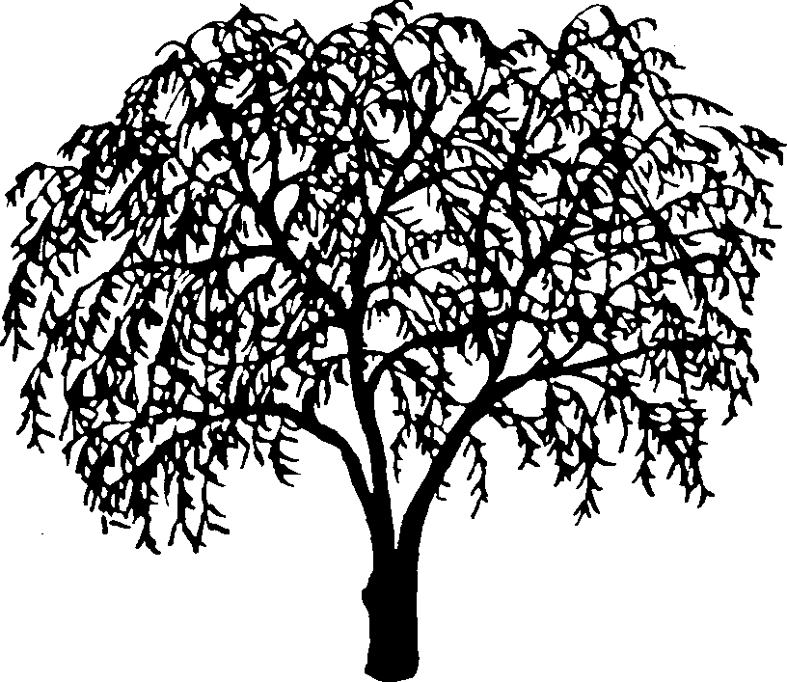Conclusion
Natureness Exhibit 38. Because most of us have had our natural world Natureness abused in some way, especially during our formative years, this Natureness article, as we find and add examples of it in a natural area, is a tool that lets us 850% better remedy our nature-prejudiced war traumas and the Earth Misery Climates they create everywhere because their essence always exists in spacetime. My narrative achieves this by scientifically affording safe reconnection space in attractive natural areas and gaining consent from them to let us connect with what attracts us there so that we may discover that the real Natureness last name we all hold in common is “Spacetiming,” Nature’s continual love to begin life as us using words.
At this moment and forever, until new evidence updates it, this 54-sense article lets anybody become our Natureness in any relationship or discipline once they know their Natureness. That’s our Pristine Truth in action, 0 or 1. It’s omission increasingly creates our Earth Misery Climates. The conclusion is that we must replace omitting it with Natureness spacetime moments that let Earth teach. You can facilitate this by participating via (Cohen, 2021, 2022).,,,,,,,,,,,,,,,,,,,,,,,,,,,,,,,,,
Does this “Epitome of Natureness” activity help? (Cohen, 2021A)......................
Some evening Youness, with some Ness friends, meet at a place where you can see the sky with the stars out. You are looking at the beginning of space-time happening that instant. Have your essence get consent from the Universe’s life to find a ness attraction in that evergrowing space-time moment where everything including you is Natureness’s self-correcting essence in action.

Ask that attraction what it would like you to know about its relationship with you and vice-versa.

You and your friends share what attractive things happened in the activity, what you learned, and help each other benefit from them. Include how you are attracted your sky discoveries if you find them in each other.

What values did you get from in this Natureness gathering? Do you trust them?

REMINDER. In conjunction with the instructions for achieving Natureness expertise, submitting this article with your added exhibit validations gives you advanced standing in the degree and certification training programs of Project NatureConnect.

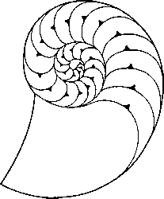
References
NOTE Most references are updated, online and in context so they strengthen, rather than harmfully compartmentalize or undermine the integrity of an exhibit’s contribution. Specific terms or topics in a reference are located by using a finder
Boyd, B. (2017)The Evolution Of Stories: From Mimesis To Language [Online] Available:https://www.ncbi.nlm.nih.gov/pmc/articles/PMC5763351/#wcs1444-bib-0002
Cohen, M. J. (1983). Prejudice Against Nature: [Online] Available: http://www.ecopsych.com/prejudicebigotry.html
Cohen, M. J. (1989) A Valentine For Counselors And You. [Online] Available: http://www.ecopsych.com/giftvalentine.html
Cohen, M.J. (1990) The Global Wellness and Unity Activity. [Online] Available: http://www.ecopsych.com/amental.html
Cohen, M. J. (1991) Nature Connected Psychology. Greenwich University Journal of Science and Technology. [Online]Available http://www.ecopsych.com/natpsych2.html
Cohen, M. J. (1993) The Training Ground Of A Nature-Connected Expert. [Online] Available: http://www.ecopsych.com/mjcohen.html
Cohen, M. J. (1994) The Applied Ecopsychology Program. (2014). [Online] Available: http://www.projectnatureconnect.org
Cohen, M. J. (1997). Reconnecting With Nature, EcoPress.[Online] Available: http://www.ecopsych.com/insight53senses.html
Cohen, M. J. (1998) The Revolutionary Wisdom Of Eco-Art Therapies. [Online]Available:
Cohen, M. J. (1999) Who, What Or When Is The Acronym NNIAAL? [Online] Available http://www.ecopsych.com/earthstories101.html
Cohen, M. J. (1995) Counseling With Nature. The Interpsych Newsletter [Online] Available http://www.ecopsych.com/counseling.html
Cohen, M. J. (2001) The State Of Planet Earth And Us. [Online]Available: http://www.ecopsych.com/zombie2.html
Cohen, M. J. (2002) Ecozombies, be Careful. [Online]Available: http://www.ecopsych.com/zombie.html
Cohen, M. J. (2003). Web of Life Imperative, [Online] Available: http://www.ecopsych.com/zombie.html
Cohen, M. J. (2007) The Hidden Organic Remedy: Nature as Higher …..Power. [Online] Available: …..http://www.ecopsych.com/nhpbook.html
Cohen M. J. (2008) Educating, Counseling and Healing With Nature. [Online] Available: http://www.ecopsych.com/ksanity.html
Cohen, M. J. (2010). Planet Earth is a Living Organism. [Online] Available: http://www.ecopsych.com/livingplanetearthkey.html
Cohen, M. J. (2011) Thinking And Learning With All Nine Legs. [Online] Available: http://www.ecopsych.com/nineleg.html
Cohen, M. J. (2011a) The Anatomy Of Institutions. [Online] Available: http://www.ecopsych.com/journalinstitution.html
Cohen, M. J. (2012) A New Copernican Revolution. (2012). Journal of Organic Psychology and Natural Attraction Ecology, 2. [Online] Available: http://www.ecopsych.com/journalcopernicus.html
Cohen, M. J. (2015) A Survey Of Nature-Connected Learning Participants. [Online] Available: http://www.ecopsych.com/survey.html Search word: “other research”
Cohen, M. J. (2016) With Justice For All. [Online] Available: http://www.ecopsych.com/grandjury.html
Cohen, M. J. (2016a). How To Liberate Your Natural Essence. [Online] Available:
http://www.ecopsych.com/GREENWAVEBETAFINAL.pdf
Cohen, M. J. (2016b) Liberate Natural Essence. Search word: “film”
Cohen, M. J. (2016c) Liberate Natural Essence. Search word: “Appendix B”
Cohen, M. J. (2016d). Liberate Natural Essence. Search word: “Appendix A”
Cohen, M. J. (2017). The Scientific Core Of All Known Relationships: Attraction Is Conscious Of What It Is Attracted To. [Online] Available: http://www.ecopsych.com/SCIENCEVALIDATION.pdf
Cohen, M. J. (2018) Thinking Like Natureness Works [Online] Available: www.ecopsych.com/journalslimemold.html
Cohen, M. J. (2019). The Project NatureConnect Certification And Degree Training Program. [Online] Available: http://www.ecopsych.com/CANTEENTRAINING.pdf
Cohen, M. J. (2019a) The Revolutionary Wisdom and Science of Eco-arts Therapies: A Practical Skill and Truth [Online] Available: www.ecopsych.com/journalmist.html
Cohen, M. J. (2020) Your Greatest Trustable Truth Interview With Mike Cohen [Online] Available: www.ecopsych.com/janetinterview.html
Cohen, M. J. (2020a) Your Natureness Search word: “ego”
Cohen, M. J. (2020b) Climate Therapy: Trust Revolutionary Wisdom [Online] Available: www.ecopsych.com/climatetherapy.html
Cohen, M. J. (2020c) News Media and UN Secretary General Accused of Negligence[Online] Available: www.ecopsych.com/UNwaronnature.pdf
Cohen, M. J. (2020d) Climate Therapy: Does It Make Sense For You?[Online] Available: www.ecopsych.com/www.ecopsych.com/ctquotes.html
Cohen, M. J. (2021) GTT Affirmation Phone Numbers [Online] ……Available:http://www.ecopsych.com/GTTPHONE.pdf
Cohen, M. J. (2021a) Pure Science Illustrated: The History of
Nature's Life, Space and Time [Online] ……….Available:http://www.ecopsych.com/natscience.html
Cohen, M. J. (2022) Climate Therapy and Natureness [Online] Available ……,,,,,,,,,,,,….www.ecopsych.com/journalnatureness.html

Cohen, M. J. (2022a) Science Illustration: The History of
Nature's Life, Space and Time [Online] Available: ………www.ecopsych.com/naturenessnow.html#illustration
Global Footprint (2021) Earth Overshoot Day [Online] Available: https://data.footprintnetwork.org
Hoke, P. (2015) Maverick Genius At Work, You Be The Judge. Retrieved from http://www.ecopsych.com/think3genius.html
Klepeis, N.E. (2001) The National Human Activity Pattern Survey (NHAPS) [Online] Available: https://www.nature.com/articles/7500165
Mallory, S. (2017) The Accepted Proposal For A Ph.D. by Stacey S. Mallory, M.S. [Online] Available: http://www.ecopsych.com/journalproposal.html
Uhl, C. (2016) The Root Cause of Climate Change [Online] Available: https://www.humansandnature.org/The-Root-Cause-of-Climate-Change
Weir, K. (2020) Nurtured by Nature [Online] Available: https://www.apa.org/monitor/2020/04/nurtured-nature

Bibliography
Cohen, M. J. (1997). Reconnecting With Nature, EcoPress.[Online] Available: http://www.ecopsych.com/insight53senses.html
Cohen, M. J. (2003). Web of Life Imperative, Trafford [Online] Available: http://www.ecopsych.com/ The Web of Life Imperative.pdf
Cohen M. J. (2008) Educating,Counseling and Healing With Nature. [Online] Available: http://www.ecopsych.com/ksanity.html
Cohen, M. J. (2016) With Justice For All. [Online] Available: http://www.ecopsych.com/grandjury.html
Cohen, M. J. (2016a). How To Liberate Your Natural Essence. [Online] Available: http://www.ecopsych.com/NATURENESSBETAFINAL.pdf
Cohen, M. J. (2007) The Hidden Organic Remedy: Nature as Higher Power. [Online] Available: http://www.ecopsych.com/nhpbook.html
Cohen, M. J. (2020b) Climate Therapy: Trust Revolutionary Wisdom [Online] Available: www.ecopsych.com/climatetherapy.html

