Project NatureConnect
P. O. Box 1605, Friday Harbor, WA, 98250 360-378-6313 <nature@interisland.net>

Educating Counseling and Healing With Nature www.ecopsych.com
- Master sensory methods and materials that help us strengthen the dance of nature's peace and sanity, in and around us.
- Establish a socially and environmentally responsible relationship-building and stress-reduction livelihood or hobby.
- Benefit from grant funded, online, Ph.D., M.S., and B.A. degrees/courses/training.

Explore Nature’s Revolutionary Wisdom in the Unified Field

Let yourself measure your own well-being according to your self-evident sensory contact with nature, not by what you have read or what others tell you.
– Stacey Mallory

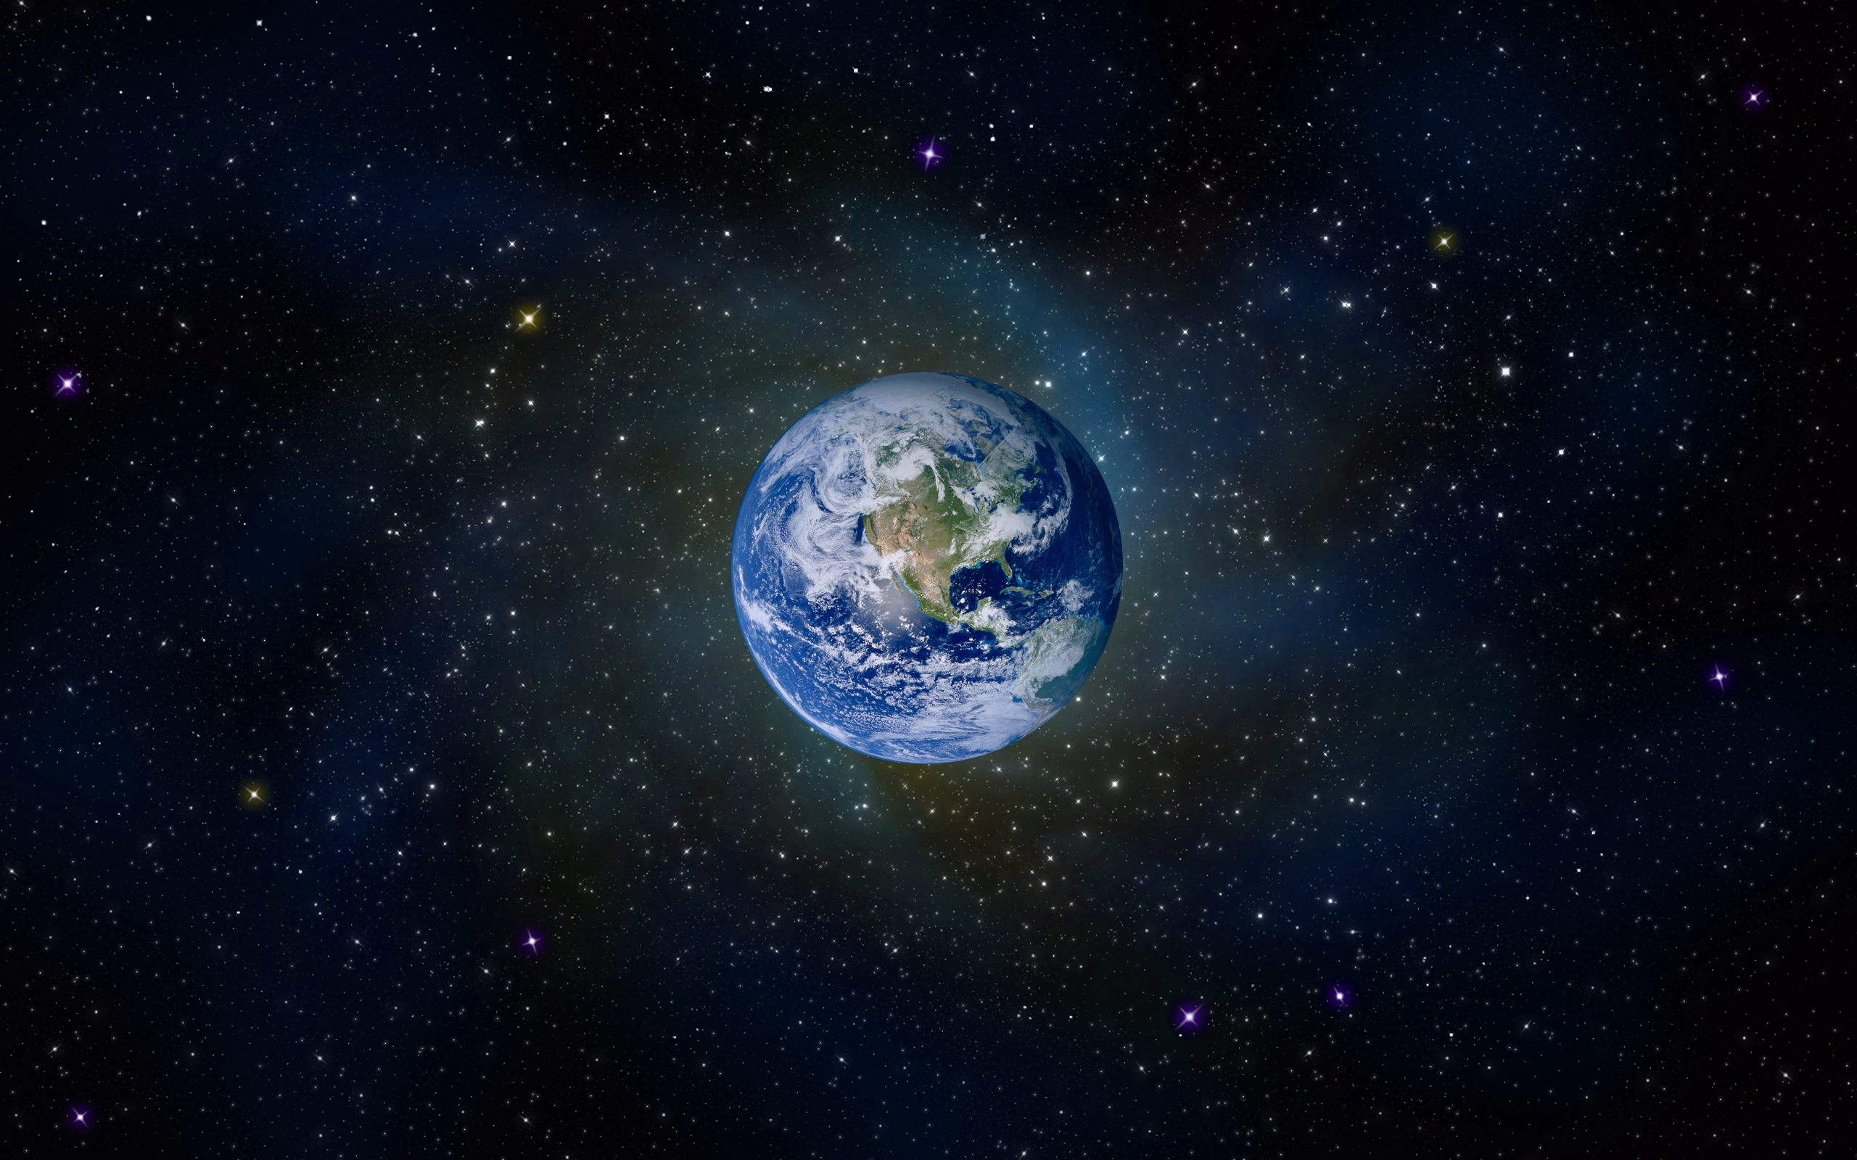
The life of Earth in and of the Unified Field

A Synopsis of the Unified Field GreenWave
- Michael J. Cohen, Ph.D.
It should be possible to explain the laws of physics to a barmaid.
- Albert Einstein

The steadily deteriorating quality of life on Earth demands that we embrace the life of the Truth of Now (TN), space/time Universe and its unified field that Albert Einstein predicted in 1935 and that was confirmed in the 2012 Higgs Boson discovery. It’s life since its Big Bang birth is the core reality and knowledge of how the life our Planet, including humanity works because it is it. It has too long been ignored along with the evidence-based scientific methodology that validates it.

Like building and using eating utensils or driving an automobile, the space/time Standard Universe is accepted as dominant common knowledge. It is part of the central and established ways of thinking and relating that sustain contemporary society. This is similar to today’s use of a computer or to plate tectonics influencing the Earth’s geology. Both were little known sixty years ago.

You inherit and are part of the space/time Universe and its Unified field because you are part of the Web of Life, part of the life of Nature. Consciously connecting with it in natural areas helps you and others think, feel and relate one Truth of Now(TN), giant step further into increasing personal, social and environmental well-being. This is different than the excessively nature-disconnected way we presently operate. The latter produces rather than reduces our disorders.
The one TN giant step is to be scientifically wise enough to recognize that in the life of our Big Bang universe of atoms and galaxies, your life is like being on the crest of a growing energy wave that only exists in the present moment.

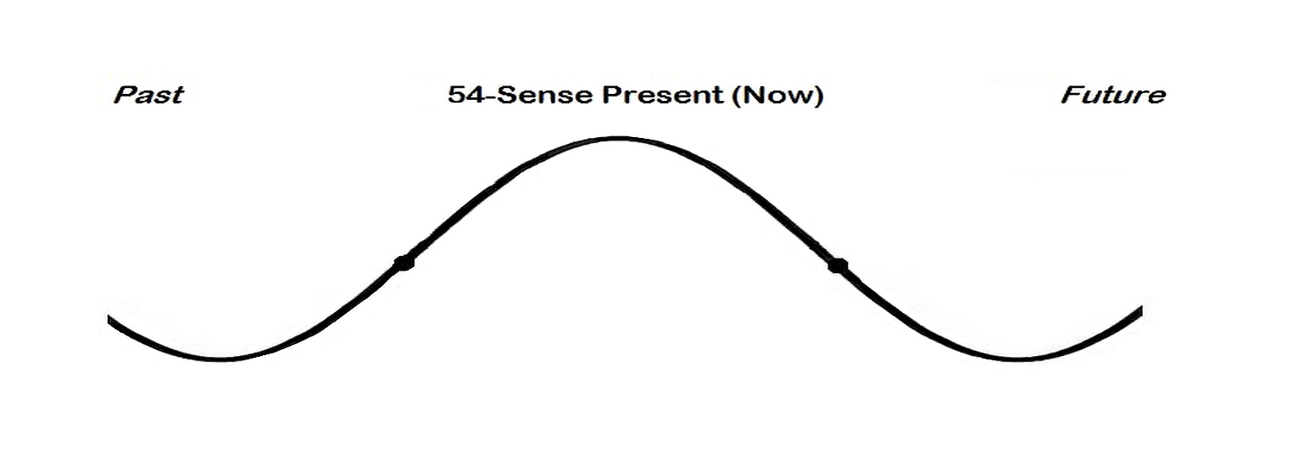
The story of contemporary science is that from the crest, you can see the past, but you can't influence it because you are on the wave of the present.
Ahead you can see the possible future, but you can't be there to influence it because you are on the wave of the present.
The wave is this instant, the now of Nature. It is the only time and place where your 54-sense intelligence can exist and be aware of the past, present and future as well as make changes for the better in that moment. The reason for this is because the space-time life of our Planet and the Universe only builds itself and exists in the present crest moment. Consciously connecting to the crest connects your senses, thinking and feeling to the totality of the creation process creating itself including you. That is a basic law that all of our amazing technologies and wonderful human relationships are built from. It’s the Truth of Now, the only moment when you can actually take a deep breath. It is the reality that most therapies use to help you, yet seldom identify.
The difference between past, present, and future is an illusion; they all exist simultaneously.
- Albert Einstein, David Bohm, Carl Sagan, Alan Watts

Riding the Wave powerfully helps any individual who recognizes that this singular fact is self-evident:
That you are reading these words right now obviously is in the present time and space. It is real, it needs no proof or defense. It is a pure Truth of Now fact of the wave crescent, the life of Nature, creation and wisdom in action.

Most important, you and everybody else trust this “Now” form of truth. The Truth of Now (TN) is an inborn, self-evident and unifying means of relating and communicating that we naturally hold in common. It is Nature itself, the fountainhead of authority in how it works. To our loss, our established ways teach us to disregard or conquer this certainty.

The TN fact is extraordinarily reasonable because self-evidence is undeniable. As part of any experience, it is always available in every TN moment of the Universe. This is because experience and self-evidence are TN real. Self-evidence registers, unadulterated, directly in our body, mind, and spirit through some or all of our 54 natural senses and, like all things, they, too, only exist in the TN moment. Self-evidence includes, right now, you TN experiencing your senses of sight, reason, consciousness, motion (scrolling, cursor, eye movement), literacy, color, design, trust and place registering and knowing this TN moment on this page to this period.

The only source of knowledge is experience,
- Albert Einstein.
By omitting or denying TN and the wave crest of our Universe, the world is increasingly unable to unify. In painfully destructive ways we see, sense and feel the life of Earth falling apart in individuals, society and the environment. We see, too, that we are unable to stop this growing lack of peace, sanity and resources while our extinction of species, climate change, mental illness, obesity and most other disorders is steadily increasing.

You can trust the TN self-evidence of your experiences when you understand, as did Albert Einstein in 1935, that his sense of reason helped him deny the Steady State theory of the Universe. He realized that the singular Big Bang sequence of the Universe, that our Planet and we live in, makes its own TN time and space moment-by-moment. This was more reasonably evident that the alleged appearance of unexplainable phenomena from unknown sources sustaining the Universe.

Einstein immediately recognized that the expanding time/space continuum had to have a central Unified Field, an attraction network of the Universe that kept all its parts in communication and relationship with its TN wholeness and each other, moment by moment. He knew that to be part of a system a thing has to be in TN communication with the system otherwise it can’t coordinate with it, it trespasses it and becomes the functions of an outlaw.

Look deep into nature, and then you will understand everything better.

- Albert Einstein
The Big Bang theory and its TN Unified Field became a completed fact in 2012 with the discovery of the central Higgs Boson attraction particle and net in quantum and particle physics. It, along with other attraction fields like gravity and cosmic forces, was Einstein’s predicted Unified Field. It includes the fact that any given moment the Universe is a single, sequential, continuing, universe wide-and-deep unifying energy, a TN wave that continually builds a different TN next moment for itself.

The Big Bang is considered to be the birth of our Universe. Things that are born are alive. Birth is a biological process, bio meaning life.

Like the TN sequence of a seed maturing into a tree, the Big Bang Universe “seed of life” was and still is attracted to (loves to) continually create the life of its own more attractive TN time and space. This is how its life survives, it is attracted to and loves to live. This is equally true of the life of any seed, egg, molecule, atom, sense or idea. It happens because they all bud from and are part of the science-based, foundational Universe, seed of life, wave crest process. Each is a hologram, a part of the life of Earth that TN moment-by-moment loves to build its next TN moment and space. It is how and why a seed becomes a flower and a molecule becomes a crystal. It is accurately symbolized by the sequence of numbers in mathematics, too. That is why mathematics works and its progression (progress) is scientifically TN accurate: 1 2 3 4 5 6 7 8 9. It is no accident that all things love to follow this “tree of life” sequence, rather it is because all things are TN part of that love to continue its life moment-by-moment. This affirms Einstein’s observation:

All religions, arts, and sciences are branches of the same tree.

- Albert Einstein.
The singular TN Unified Field core of everything in the life of any universal time-space moment is significant. Since it is the Universe growing its own time and space. It means the essence of all things in any moment are identical including the life of Earth, you and me. Through the Unified Field we are all at an attractive, unifying, growing oneness of the universal TN life of Nature and each other, around and in us, moment by moment.

As human beings, we are each our own unique personification Nature’s life and the Unified Field that is attracted and loves to grow into being each of us into the next TN moment as an ongoing part of Nature, Earth and humanity.

A human being is part of a whole called by us the universe.

- Albert Einstein
Our sense of reason registers that if you and I know we are alive and love to be alive in any TN moment, we scientifically know as well that the essence of all things in that space-time moment are TN identical. This means that logically, the essence of all things must also be alive and in attractive, loving communication in that moment including Planet Earth and the Universe itself. Our 54 natural senses, also being in-the-moment alive, register that communication and can modify it in the moment so we can uniquely TN speak and think with it. We are the only part of the life of our planet that can do this, that can speak with words and stories.

With our TN stories we are consciously able to think and make our posture and the life of Earth more coordinated, attractive and reasonable in the next moment. This triggers feeling of TN love and happiness from sensing itself. This is because nature loves to support our life as its life and vice-versa, because nature loved us into being its/our aliveness in this moment.

Everything is a seamless continuum of the original energy aliveness of the Universe, the TN seed of the tree of life that burst into existence as the Big Bang and continues to create its own time and space, moment-by-moment. This means that scientifically any single thing is TN attached to all that came before it and all the follows it during the moment it is in the crest of the wave. This includes each of our 54 natural sensibilities except one. The one is our all too common nature-disconnecting story that denies the TN validity of scientific evidence and relies on false, NOT-TN mystical and supernatural beliefs when relating to nature. Implementing that NOT-TN story is like hiring a lobster to operate the control tower of Chicago International Airport…as the present state of the world shows.

Our task must be to free ourselves by widening our circle of compassion to embrace all living creatures and the whole of nature and its beauty.

- Albert Einstein

Consider this example of trying to be TN aware of your fifty-four senses while in the wave crest time and space of natural area, moment-by-moment:

“Walking along the edge of the coast, I TN saw three White Egrets and One Great Blue Heron. The water seems to be a clear dark blue at the edge. (#30 sense of physical place) I feel the wind in my hair, (#14 feel touch on the skin) with air with a slight chill to my skin that made my body feel chilly (#7 sense of temperature)

The sky was filled with pink multi-dimensional clouds that seemed to radiate out above and all around me (#4 sense of light and moods attached to colors, #16 space/proximity sense, #41sense of form and design). Absolutely incredible!
‘Wow!’ I said to myself. ‘It seems to be radiating right toward me.’(#39 language and articulation sense, #43 sense of consciousness & #35 sense of self including friendship, companionship, & power)
I found myself running through the crisp morning air (sense of temperature,) to get a clear view (# 42 sense of reason, #18 sense of motion and space and #5 awareness of one’s own visibility).
I sang out my thanks (#35 sense of emotional support, belonging, support, trust, thankfulness). As I twirled, arms outstretched, the sky turned from pink to gold (#18 sense of motion, #29 play, pleasure, laughter, place, #17 coriolus sense or awareness of effects of the rotation of the Earth). The rising light danced off the expanding shapes (sense of #4 sight, color, #41 distance, and design).
I called my TN aloud, ‘Thank you dear clouds for helping us to feel our connection to all things and to all living beings!!!!’ (#40 sense of appreciation, humility, and ethics)
I felt as if I was being watched over and supported. (# 44. #43 sense of intuition, deduction, sense of mind and consciousness).

All of my personal senses and sensations took place in, were part of and contributed to the now, the present time-space moments of the TN wave crest that started with the Big Bang 13.8 billion years ago. This means that what I love to sense, think and act now will be part of and influence the next moment of the life of Earth. This feels good. It helps me realize that there is a TN level, supportive playing field in Nature and that my life contributes and has value and can help shape it in a good way.

Since we were children my older sister, and I have always argued, but after I connected with the clouds I felt a special TN sense of self-recognition and appreciation. I recognized that feeling was what I was missing from my sister and that I did not need to get it from her, I could get it from the clouds and other nature connections, and I continued to do so (#43 consciousness, #42 reason, #39 language/stories) . Things are better now. I no longer argue with her and we respect and love each other more (#54 whole life attraction).”

Education is what remains after one has forgotten what one has learned in school.

- Albert Einstein

You can TN integrate your biological and cognitive interactions with Nature into life systems unfolding around you.
Actively use your inherent TN senses to determine personal attractions in nature and more fully understand the complex web-of-life model and how humans play an active role in the process by directing their TN attention to their multiple sensory attraction-bonds in nature.
Review the list of Fifty-Four senses. Each of the is TN in action. Identify which of them you think you have experienced at one time or another.
Let your senses of consciousness #43, reason #42 and language #39 consider the following;
- “Every 5-7 years, TN moment by moment, every atom in our body is replaced by other atoms from outside of our body. This same process goes on with everything else in the web-of-life at various speeds.
- The fact is that 10-15 times during a normal human lifetime we slowly become the life of our Planet, and it becomes us.
- We live in, not on, the TN life of Planet Earth. We live in the bottom of its atmosphere, underneath it clouds, wind and flying creatures. We live as a part of its biosphere as it streams through us, bio meaning "alive."
- Our bodies consist of ten times more foreign cells than human cells.
- About thirty percent of our genetic makeup is plant DNA.
- All our cells consist of atoms and molecules produced by stars ten billion years ago.
- As part of, and like the life of Earth and Nature, we are attracted to survive into the next moment. That can be the TN purpose of life.
- Some of our senses can feel good when seeing a beautiful image or film about Nature, but all 54 of them in congress are stressed because they know they can’t eat, drink or swim in the picture. This misleading disconnection continually produces the mistrust and isolation we suffer while we learn to call it progress.
Step outside to a natural area. Ask for its consent to think, feel and co-abide with all other life forms and life processes in this area. Take a loving TN walk through your immediate landscape and follow attractions to fifty-four TN senses that register as you walk.
Notice the senses you are using to perceive the natural world as you walk through this TN time and place. Think of this walk as you walking through yourself and making sensory contact with the TN rest of you as you grow into the next time/space moment of the eons. Doing this brings you to the life of Earth’s TN story, a story that the central thinking of contemporary society denies. It believes that we are different than, separate from and more intelligent than the life of Earth. The results of that NOT-TN fable generate a questionable story, a divisive one that isolates things and guides us to produce our TN destructive effects.
Try to be aware of how your fifty-four senses, your TN non-verbal, love of life communications with nature, help you sense that you are in the Living Universe, in the life of Planet Earth as you walk, not just on it. Note the impact or how you navigate your landscape and might enhance a more fully interactive experience in Nature. Sometimes it helps to verbally call a natural area your own name or think of it as you being in contact with your mind or your subconscious forty-nine additional TN senses to our common five senses. Sometimes call it attraction-in-action, knowing yourself attractively.
Keep in mind that this fifty-four sense TN connection story of yours supports the life of Earth’s ability and attraction or love to balance its optimums of diversity, beauty, purity, peace, wellness, and cooperation. It achieves this without producing our garbage, stress, and abusiveness. It helps you TN sense and love that you are part of and in balance with the Big Bang Universe tree of life in this wave crest moment.
How does this self-evident truth of your TN story and sensations being scientifically unified feel? What TN emotions do you experience?
Recognize that on average, in contemporary society, over 95 percent of our time and 99 percent of our thinking and feeling are excessively disconnected from how the self-correcting TN ways that the life of authentic Nature work in and around us. Instead, we spend this time in homes, schools, vehicles, and business or entertainment buildings while communicating and learning through NOT-TN stories and media that the life Nature neither understands or uses. It is it is silent, it does not speak, read or write so it is vulnerable to our NOT-TN acts as the deteriorating state of the world demonstrates. Our 54-sense, organic art and science relationships empower us to remedy this catastrophe.
View the ten-minute video at https://vimeo.com/211249559
For a double-blind peer-reviewed article that validates the 54 sensce, TN art and science of Organic Psychology visit http://www.ecopsych.com/GREENWAVEBETA.docx

Summary
We suffer our problems and unhappiness because we are socialized to deny this scientific truth: as part of the time-space life of Nature and Earth’s unified dance, moment-by-moment our TN fifty-four natural senses attach us to all that has preceded us and all that follows us. Senses that are wounded by abusive relationships remain wounded. We feel and act accordingly until we create space for these senses to happily reattach to their TN origins in the purity and power of Nature/Earth’s self-correcting balance and beauty, not to NOT-TN substitutes for the wisdom of its dance. It is our NOT-TN nature-disconnecting attachments to inferior Nature-substitutes that are not self-correcting and make us produce and suffer our disorders.

Insanity: doing the same thing over and over again and expecting different results

- Albert Einstein

Conclusion
If this TN article makes sense to you, and you are attracted to master this subject through other articles, courses, a degree or certificate with Project NatureConnect, please call us and follow the links and contact information below. The more your story/information way of knowing TN connects with and accurately represents the TN non-story way Nature works, in and around you, the less stress and disorders you experience, the clearer and happier you think, feel and relate and the more you can help others do the same. Because TN is lastingly therapeutic, there is a great need to do and teach it in the world today.
Learning and Livelihood Opportunities
- Orientation Course http://www.ecopsych.com/orient.html
- Certification Revolutionary Wisdom Book/Course http://www.ecopsych.com/54rwbook.html
Our three additional courses will award you a Certification, B.S., M.S. or Ph.D. in Organic Psychology or Eco-Art Therapy in as little as 18 months when you include your years of previous training and life experience in the coursework.
http://www.projectnatureconnect.com/
To sign up for these courses or for any questions, please feel free to contact:
Michael Cohen at nature@interisland.net Phone: 360-378-6313
Stacey Mallory Stacey@connect2nature.org Phone: 479-677-3328

